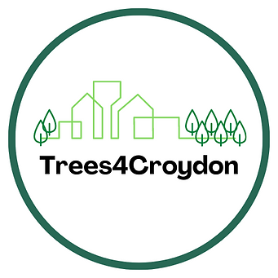
TREES4CROYDON

Croydon Climate Action is running a Trees4Croydon campaign to increase tree cover in Croydon especially in areas of green space deprivation!

GET MOVING FOR TREES

This is an ambitious and exciting project to ‘green up’ parts of the borough.
Benefits from tree planting include:
- More equitable access to trees/ green spaces in the borough;
- Enhanced biodiversity;
- Greater carbon sequestration; and
- Cooler neighbourhoods.

A great deal of planning has already taken place and pledged funding is being secured from Croydon businesses, donations and grants. People are being asked to move – walk, run, cycle or in a wheelchair – during the 5 weeks from 10th June to 15th July. You DO NOT HAVE TO SPONSOR YOURSELF OR ANYONE ELSE (although there is that option). The ask is that you move and record how many miles you cover each day or week. The miles covered will release corporate and business sponsorship as third-party funding. A number of families have already registered their Moving For Trees team and so far some of the following organisations include – Purley Cubs, Croydon Cyclists, Sanderstead Cricket Club, Downsview Primary School, Coversure Croydon, Oxted Walkers, Sustainable Thornton Heath, St Peter’s Primary, Barclays, Croydon Voluntary Action and Croydon Vision. fight clim

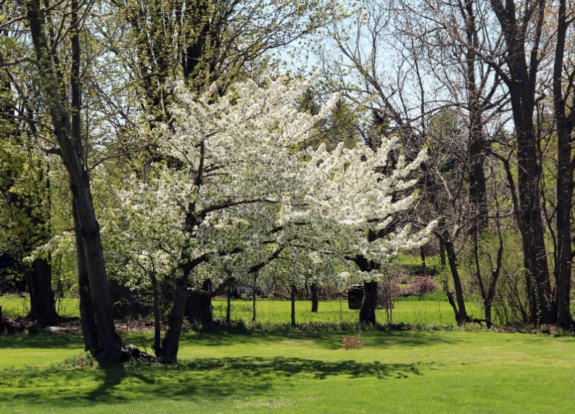
GET MOVING
4 TREES

WHAT’S NEXT?
I REALLY WANT CROYDON u3a TO BE PART OF
THIS INITIATIVE TO ‘GREEN UP’ PARTS OF CROYDON
AND I HOPE YOU WILL SUPPORT ME.
This might involve racking up your regular walk to the shops or with the dog, a special walk in the park with friends, a cycle ride, ramble or stroll in the woods, taking the grandkids to the park, walking for your wellbeing (and swimming can be included).
- I will Register Croydon u3a team with numbers TBC.
- Tell me you want to be on the Croydon u3a Get Moving 4 Trees Team – email jennywilson63@live.co.uk OR Tel or text 07686 723 686
- I will record how many members make up our team and get the ‘app’.
- During the 5 weeks from 10th June to 15th July you let me know how much ground you have covered (roughly) in miles and I will upload our team’s total.
- Our total mileage will be added to the total for Croydon residents, their family & friends (people don’t have to live in the borough).
- Businesses supporting Trees4Croydon will provide funding according to their pledges which will then be matched by Trees for Cities which is a UK charity. Since 1993, the organisation has planted over 1,200,000 trees in parks, streets, woodlands, schools, hospitals and housing estates.
- Once the money is realised, plans for the siting and planting of the trees will be actioned. It is expected that planting will take place during the spring of 2024.
Please visit https://www.croydonclimateaction.com/trees4croydon
where you will find more detail information about the planning processes, registered charity involvement, future responsibilities and further opportunities with the planting.
PLEASE HELP ME PUT CROYDON u3a
out there as an active and future focused organisation
Jenny Wilson (Chair)

