New Ideas
One of the great things about my role as Interest Groups’ Coordinator is that people keep coming to me with ideas about starting new groups!
Usually, this happened when one of our members comes up with a plan to start a group based on an interest they have and would like to share with other Croydon u3a members. Sometimes, however, they just ‘float’ an idea about something they feel would be attractive to members.
Recently, some new ideas for groups were suggested to me which seem to be potentially interesting for our members and I would be willing to take them forward if enough people show an interest. Walks Group for the mutual benefit of both groups.
If you are interested in leading this new group, please contact me at: clockie68@gmail.com
Maggie Chan, Croydon u3a Interest Groups Coordinator

Do you need help with a laptop, mobile phone or
tablet?
Drop in for support and advice every second Wednesday from 1 pm before the General Meeting in the main hall at Croydon and District Masonic Hall, 73 Oakfield Rd, Croydon CR0 2UX.

Riverside & Canal Walks (3)
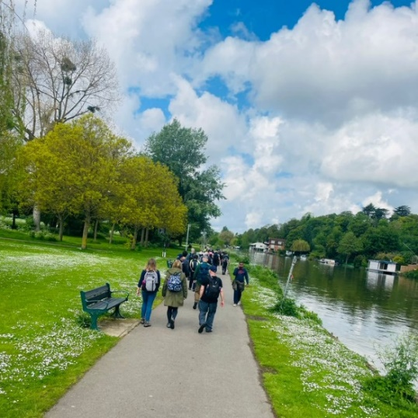
Now being set up to meet demand from members as the first two Riverside and Canal Walking groups are full! The group will follow the same format - to enjoy leisurely two-to-three-mile strolls along rivers and canals and around reservoirs.
Taking place on the 4th Tuesday of the month running from June to October.
Contact: Sandra Hill: sandrag.hill@virgin.net 07906 077931

8
Jigsaw Puzzle Experience
Anyone interested in doing jigsaw puzzles or is a jigsaw fanatic? We are starting a new group whereby jigsaw puzzles can be exchanged or borrowed. We have a selection of 1,000, 500, 350 (large pieces) puzzles, which could suit anyone. Come along on the 3rd Monday of the month at 2 pm – 3.30 pm, starting 17 June, to 37 Albatross Gardens, Selsdon Vale CR2 8QW and have a look at the various puzzles available, and bring along any that you would like to exchange too (must be complete), and also enjoy a cup of tea or coffee and biscuits, and a chat.
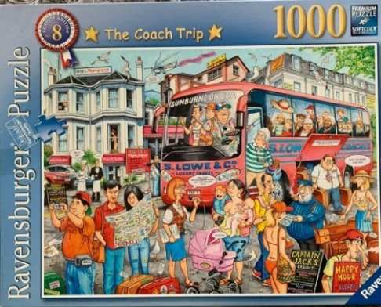
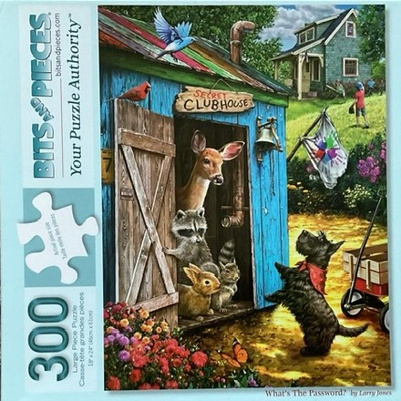
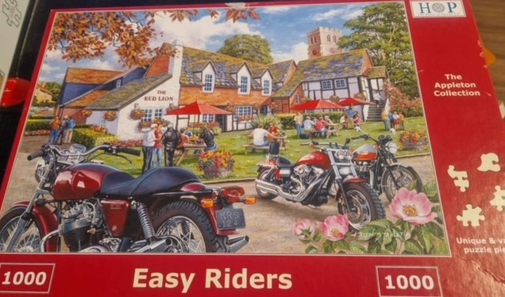
Contact Linda Grigsby on 07754 092042, or Trish Bishop on 07711 229899

Bowls Taster

Further to my article in the latest copy of the magazine, Bethlem Royal Hospital Bowls Club (BRHBC) have once again offered taster sessions to u3a members. If you have often thought about trying the game, now is your chance.
The sessions will run for three Monday mornings, June 3rd, 10th and 17th 10am to 12.15.
The cost is £3 each per session and includes coaching, equipment and refreshments. No special clothing is required apart from flat soled shoes.
If you are interested in taking part, please contact me and full details will be provided.
07955 310 826 (I am on WhatsApp)
tess.exlunn@gmail.com Tess Smith
Croydon u3a Development Plan for 2024 -2025
After some delay due to health issues of the lead committee member, we have now published the plan to take us forward into next year. You will find the full document on the website on the Governance page: https://u3asites.org.uk/croydon/page/109995

