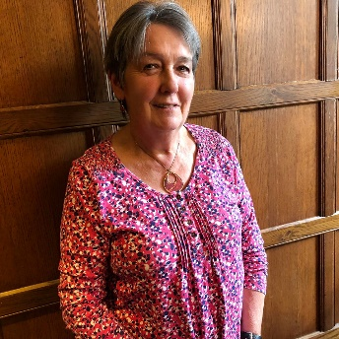  Sally Bitten  Speaker Secretary | 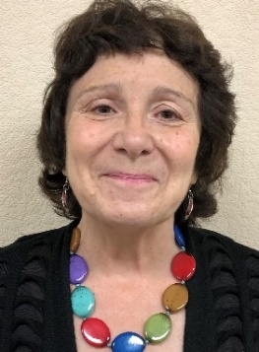  Cariss Smith  Chair – Travel Team | 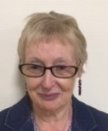  Lesley Wood  Member Support |  | 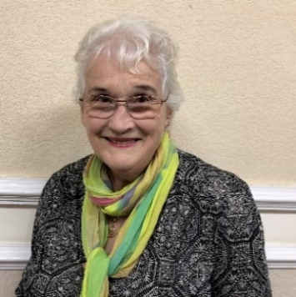  Mary Randell  Website Editor
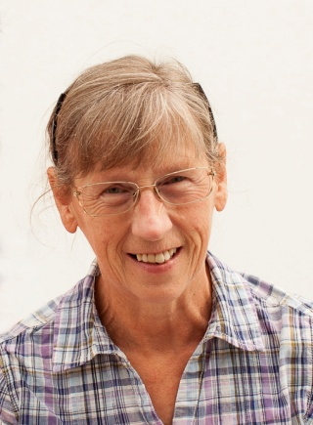  Margaret Derrick  Facebook Facilitator | 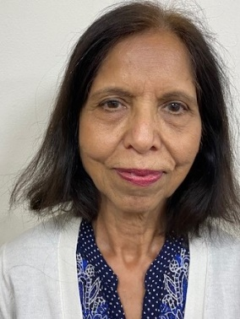  Chandra Nihalani  Venues Assistant | 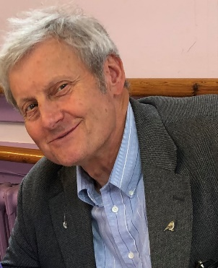  Glenn Morfill  Main Entrance/ Welcomer |  | 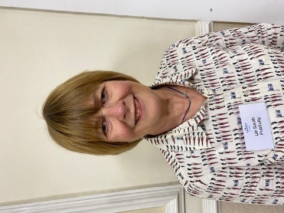  Liz Smith  Publicity Team
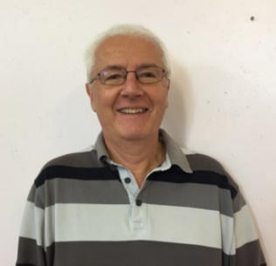  David Apps  Beacon Administrator/Travel Team | 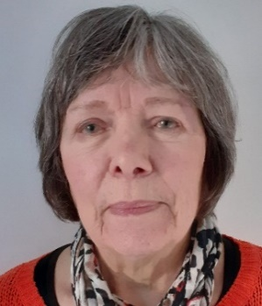  Jenny Parry  Interest Groups Team | 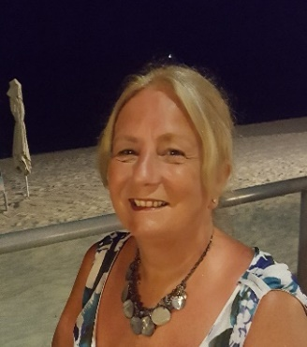  Tess Smith  Magazine Editor | 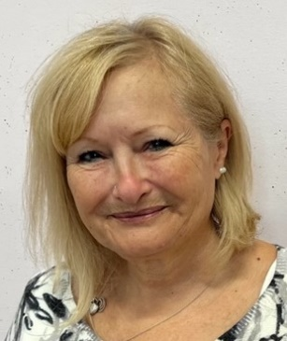  Angie Stagg  New Members Support
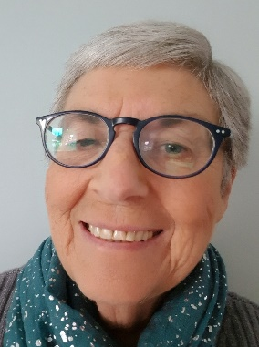  Val Apps  GM Welcomer | PLUS:  Christine Crawley – Diary Orders  AND ALL THE GROUP LEADERS AND THEIR ASSISTANTS WHO ARE WORKING HARD TO KEEP GROUPS FUNCTIONING AND SUPPORTING ONE ANOTHER |  | 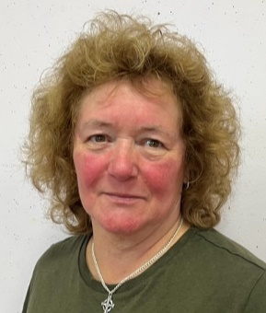  Anne Tanner  New Members Support

