The u3a Trust’s National Chair, Liz Thackray, visited Croydon on 15th January and had discussions with a considerable number of members. I thought she was visiting to have conversations with members about their u3a experience, so I invited a cross section of us. It turned out that Liz was visiting us so we could get to know her and more about the Trust. I have to say that I was disappointed. The Trust always flags being a ‘bottom up’ organisation, and this would have been a perfect gathering to hear from established members, very new ones, Group Leaders and a couple of Committee members…… Oh well you can only get it right some of the time. I did quietly voice my feelings that it was a wasted opportunity, and I did subsequently receive a thank you note from Liz.

My main feedback is that everyone person I asked to take part said yes with no hesitation, such is our collective commitment and enthusiasm for our u3a.

Thank you to those members who gave up their afternoon.

**The u3a’s 40th Anniversary**

The first ever **National Festival** is being held in York in July to celebrate and is offering a wide range of activities and events all run by volunteers = see p.19 of Third Age Matters and the website :- <https://www.u3a.org.uk/events/festival-2024>

If you have any plans to visit that part of the country, the programme will be available soon, when you will be able to sign up as a day visitor or even attend for the 3 days if you have nearby accommodation.

During the 40 years since inauguration the movement has undergone many changes. Have a look at your recent issue of Third Age Matters page 35 to read an article by Eric Midwinter, one of the founders. The movement started in a very small way, being run from a spare bedroom, and has now grown to over 400,000 members UK wide, with u3as in many other countries. We still occasionally get confused with Croydon u3a, Melbourne, Australia!!

The movement is organic and will continue to incorporate changes and improvements, but it is important to remember that each u3a is a separate, registered, independent charity operating within their Constitution. The Trust’s function is to support, advise and guide whether it be about contact with the Charity Commission, to be compliant, giving legal or financial advice, to providing helpful suggestions for recruitment of new members. The Trust also hosts a wide range of on-line talks and courses on a regular basis which are all free to members :-<https://www.u3a.org.uk/learning/national-programmes>.

There is also a vast offer – Interest Groups On-line - which costs an additional £12 per year but has about 90 groups and is great if there is something you wish to pursue which we don’t offer in Croydon.

<https://www.u3a.org.uk/learning/interest-groups-online/interest-groups-online-groups>

**13**

**We are 37 years young on 15th April – one of the first u3as to be established – so raise a glass and toast our good health**.

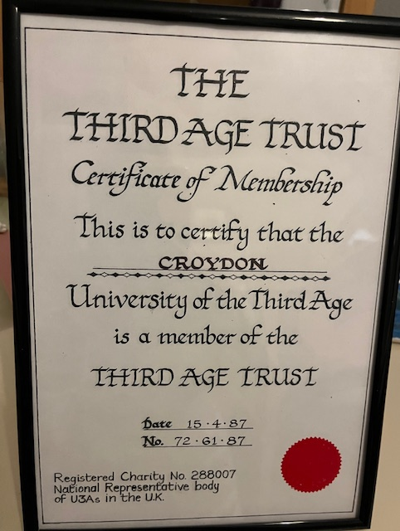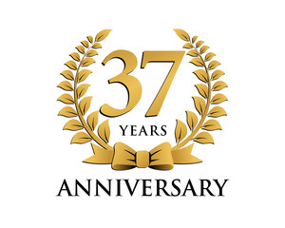

**We are Helping Two Students from The Netherlands with their Research**

We were approached about being the main contact for 2 students who are researching ‘The Power of Connection’ and specifically how membership of the u3a in general and Interest Groups in particular helps ‘we old foggies’ (ha ha) live better lives. After their first meetings, the students have been bowled over by the friendliness of members and our willingness to help their research. For me, it’s important having a two-way intergenerational benefit – they learn at first hand about the importance of the social connections we make through our learning activities and friendly events and our opinions and experiences are valued and respected. It’s a win-win. If you would like to know more and read their research proposal, email me.

**Age Friendly Forum**

The u3a has a vital role with the London Age Friendly Forum. Sam Mauger, u3a CEO, chairs meetings with 7 partners representing older Londoners. They are working to develop plans to help people live better and be safer. Currently 26% of older Londoners live in poverty compared with 16% nationally. The Forum is working to foster more positive images of ageing. Practical things such as adequate street lighting, public transport routes and schedules, public toilet availability, benches and so on are in the agenda. We are proud and encouraged that u3a is at the centre of this to influence and direct change. **March 23rd is Ageism Action Day**