Greetings from the Travel Team.
With the March Members’ Lunch and the April trip to the Beth Chatto Gardens behind us we now move on to the rest of the year’s trips.
NEW. In this Bulletin you will find the booking form for our trip in September to Wisley and the Wisley Flower Show. Plus the booking form for our August activities that are weekly through that month.
We are still taking bookings for our May visit to Osterley House and Park, and the July visit to Watts Artists Village and Loseley Gardens. Booking forms for these are in this Bulletin.
October 2024 sees another Members’ Lunch on the 16th.
November 2024 sees a short break that includes a visit to Longleat House to see visit their delightful Festival of Lights. Information in this Bulletin.
You can get more information and details on any of the above trips at the monthly General Meeting by visiting the Travel Team table.
Averil, Cariss, David, Linda and Paul
Croydon u3a Travel Team

HOT OFF THE PRESS!
Many of you members have been asking about overnight breaks. I have been seriously looking into various places in the UK and Europe for next year, and unfortunately with a single room supplement of over £200 have decided that this is not an option many of us would like to pay. If anyone has any ideas or would like to organise a trip please let the Travel Team know and we will offer our help. Linda Grigsby

19

u3a Outing to Osterley House and Park
Wednesday May 22nd 2024

Coach leaves 9.00am from Fairfield Halls, Park Lane, Croydon
Cost of the trip is £32, or £20 for National Trust Members. Price includes coach travel, driver’s tip, entry to Osterley House and Park. National Trust members get entry free to the property.
Bring your NT card with you if you are booking at the lower rate for the trip.
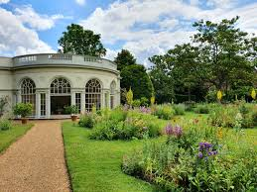
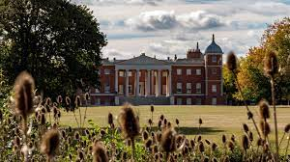

Osterley Park House and Gardens, originally a Tudor mansion, was transformed into an elegant neo-classical villa by the founders of Child's Bank. It was designed and built in the late 18th century by architect and designer Robert Adam. It has a magnificent interior, and you can also visit downstairs to experience how domestic life used to be. It is set in extensive park and farmland complete with 18th-century gardens and neo-classical buildings. The house is furnished in the style of 1780. Visit the luxurious State Rooms.
The gardens and park have been restored to their former glory which began with the recreation of Mrs Child's Flower Garden.

Return the booking form below to: David Apps, 13 Church Way, South Croydon, CR2 0JT. Tel. 020 8651 0347, with a cheque and stamped addressed envelope. We require a separate cheque for each outing. If you have problems on the day of outing, ring David 07802 769047/email: dapps97090@aol.com. At other times please use David’s landline.

Please read the Travel Team’s Terms and Conditions, on the reverse of this poster OR in the Bulletin.  ..................................................................................................................................................

BOOKING FORM – Osterley Park and House 22nd May 2024
Coach leaves at 9.00 am Wednesday 22nd May 2024. Price: £32, or £20 for National Trust Members

u3a Member - Name(s) ................................................................................. Membership No(s) …………
National Trust Membership Number (if applicable………………………………………….
Address ..................................................................................................................Post code: .............................
Tel/Mob No. ...........................................E-mail ...................................................................
I would like ...... £32 ticket(s) or ….. £20 (NT Member) tickets Cheque payable to “Croydon u3a”(enclose a sae)
My contact in case of emergency is: Name...................................................Tel. No. ………………….
REMEMBER TO BRING YOUR NATIONAL TRUST MEMBERSHIP CARD ON THE DAY

U3a Outing to Watts Artists Village and
Loseley Park gardens
Tuesday 16th July 2024
Coach leaves 8.30am from Fairfield Halls, Park Lane, Croydon
Cost of the trip is £45. Price includes coach travel, driver’s tip, entry to Watts Artists Village and Loseley Park gardens.
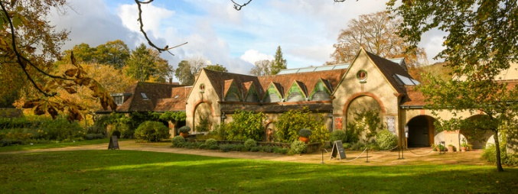
Dedicated to the life and work of Victorian painter and sculptor G F Watts and his wife, designer and artist Mary Watts, Watts Gallery – Artists’ Village is a unique Arts and Crafts gem. See where they lived and worked at their historic home, Limnerslease. Visit the magnificent Arts and Crafts cemetery chapel designed by Mary Watts. Visitors can see a world-class collection of Watts' paintings and sculptures in the Gallery.

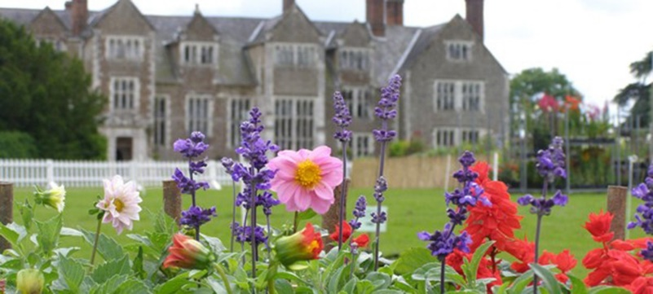
Explore 18 acres of woodland and gardens.
Loseley Park Garden. Its series of “rooms” include the award-winning rose garden (planted with over 1,000 bushes), the colourful flower garden with its maze of pathways, the white garden with fountains, and the extensive herb garden. Other features include an attractive vine walk, ancient wisteria, mulberry trees and a moat.

Return the booking form below to: David Apps, 13 Church Way, South Croydon, CR2 0JT. Tel. 020 8651 0347, with a cheque and stamped addressed envelope. We require a separate cheque for each outing. If you have problems on the day of outing, ring David 07802 769047/email: dapps97090@aol.com. At other times please use David’s landline.

Please read the Travel Team’s Terms and Conditions, on the reverse of this poster OR in the Bulletin. ...........................................................................................................................................

BOOKING FORM – Watts Artists Village and Loseley Park Gardens 2024
Coach leaves at 8:30 am Tuesday 16th July 2024. Price: £45 u3a Member/s - Name(s) ...............................................................Membership No(s) ……………
Address ..................................................................................Post code: .................. Tel/Mob No. ...........................................E-mail ................................................................... I would like .......... £45 ticket(s) Cheque payable to “Croydon u3a”(enclose a sae)

My contact in case of emergency is (not someone who is also on the coach trip):
Name…………....................................................Tel. No. ………………………………………..

u3a Outing to RHS Wisley Gardens & Flower Show
Wednesday September 4th 2024
Coach leaves 9:00am from Fairfield Hall, Park Lane, Croydon
Cost of the trip is £34 or £20 for RHS Members. Price includes coach travel, driver’s tip and entry to Wisley. RHS members can use their card (and take a guest) to get free entry.
Remember to bring your NHS card with you if booking the lower rate.
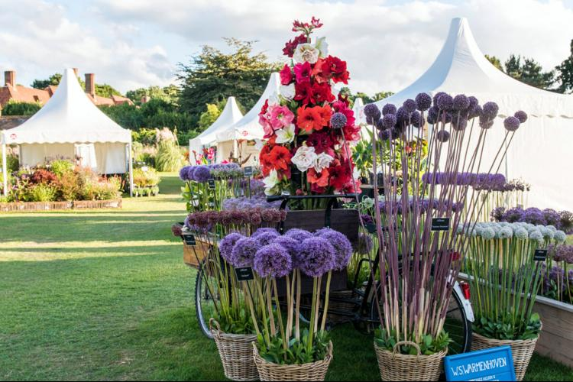
Enjoy a day at RHS Wisley Gardens at the time of their Flower Show. Browse top-quality plants and get expert advice from specialist nurseries. Enjoy exploring the colourful stands. Alongside the nurseries, trade stands provide fantastic shopping opportunities for any garden or plant lover. A wide range can be found, from pruning tools to garden art. Plus enjoy the Wisley Garden Glasshouses, Rose Garden, World Food Garden, RHS Hilltop etc. RHS Members will benefit from being able to use their membership cards (and take a guest) to gain free admission, so this trip will be £20 for RHS members (plus their guest) and £34 for non-members.
Return the booking form below to: David Apps, 13 Church Way, South Croydon, CR2 0JT. Tel. 020 8651 0347, with a cheque and stamped addressed envelope. If you have problems on the day of outing, ring David 07802 769047 or email: dapps97090@aol.com. At other times please use David’s landline. Please read the Travel Team’s Terms and Conditions, on the reverse of this poster OR in the Bulletin.

...............................................................................................................................
BOOKING FORM – Wisley Gardens and Flower Show 2024
Coach leaves at 9:00 am Wednesday 4th September 2024. Price: £34 or £20 (RHS) u3a Member/s - Name(s) .......................................................Membership No(s) …………
Address ..................................................................................Postcode.................. Tel/Mob No. ...........................................E-mail ................................................................... I would like ...... £34 ticket(s) or … £20 (RHS Member) tickets. Cheque payable to “Croydon u3a”(enclose a sae)
My contact in case of emergency is (not someone who is also on the coach trip):
Name…………....................................................Tel. No………………………………
BRING YOUR ROYAL HORTICULTURAL SOCIETY MEMBERSHIP CARD ON THE DAY

Croydon u3a Members’ Lunch

at El Patio, Selsdon CR2 8LH

El Patio, 143 Addington Road, Selsdon CR2 8LH (public transport 64, 433 buses)

Thursday 16 October 2024

12.30 pm for 1 pm

2 Courses (3 Tapas plus dessert including service charge) £21

1 Course (3 Tapas including service charge) £15

(The menu selection is on the back of this poster so please indicate on the booking form below your menu choice)

General Information and Booking terms and conditions for Members’ Lunches
Payments and Refunds: For confirmed bookings all cheques must be cleared one week before the lunch. A refund will only be payable for cancelled bookings if we are able to resell the place. Anyone taking the place of a cancelled booking must pay by bank transfer before the event or cash on the day.
Mobility Requirements: A member of the Travel Team will investigate any problems of access at the venue before bookings are opened. Members who are worried about mobility issues should contact the organiser before making the booking. Members with restricted mobility may be accompanied by a carer to any meal but a place needs to be booked. The carer does not have to be a u3a member but will be required to pay the full cost.
Your responsibilities: All attendees must carry out their own risk assessment.
................................................................................................................................................................. ……….
Croydon u3a Members’ Lunch
El Patio Tapas on Thursday 16 October 2024
at 12.30 for 1 pm
(Please make your selection here - Tapas: i)

ii)

iii)

Dessert : i) ii) iii) ……………………

Send this form to: Linda Grigsby, 37 Albatross Gardens, South Croydon CR2 8QW; Mob: 07754092042 OR Cariss Smith, 62 Penwortham Road, South Croydon CR2 0QS; Mob: 07904 163454, with a cheque payable to Croydon u3a and stamped addressed envelope or by Bank Transfer account no. 13630003, sort code 23-05-80 (YOU MUST PUT THE REFERENCE ‘MEMBERS’ LUNCH).

Name(s) .....................................................................................Membership No(s) .................................
Address: ...................................................................................................Post Code..................................
Tel. No. ..................................................E-mail ..........................................................................................
I would like ........... ticket(s) Total.............. (cheque payable to Croydon u3a and s.a.e. enclosed)

PLEASE BRING YOUR TICKET ALONG FOR ENTRY TO RAFFLE FOR A FREE MEAL
Desserts
- Almond Tart
- Profiteroles
- Churvos (Choux pastry)
Fried potatoes with garlic

Outing to Longleat Festival of Light – 3 days, 2 nights break
25th-27th November 2024

£339 per person based on passengers sharing a twin or double room (+ £99 single room supplement). £75 deposit to be paid when booking (non-refundable unless the trip is cancelled due to lack of numbers). Deadline for this is 1 August 2024. If this trip goes ahead the balance to be paid by 1 October 2024.

(Price includes coach travel, driver’s tip, 2 nights at the Limpley Stoke Hotel near Bath, excursions as described in itinerary, breakfast and evening meals). The timings of the coach leaving Croydon is to be confirmed, and will be from the Fairfield Halls. This trip is for u3a members only.

The itinerary for this trip is:

Day 1: Travel to the Limpley Stoke Hotel near Bath
Day 2: Today enjoy a day in Bath and an early dinner at the hotel before a fun-filled
evening out to Longleat – home of the UK’s first and most famous safari park. There’s so much to see and do here, and we’ll make sure there’s time to get lost in the famous maze and admire the stunning parkland around the stately home. Immerse yourself in the magic of Christmas as the Festival of Light returns, with more life-size lanterns than ever before and an iconic Winter Safari.
Day 3: Today we’ll be returning home, and an optional trip (£10)on the way home to visit the Thatchers Cider Farm. A word of warning: The actual tour is around 1$½$ hours long and during that time there is nowhere to rest or sit, we do find the more elderly and those with walking difficulties find it difficult to get around the whole tour.

Please ensure that we are aware of any mobility problems you may have, and you must tell us if you are bringing a wheelchair or mobility aid. You must also be able to get on and off the coach unaided.

To avoid disappointment please DO NOT send any deposits until we know that the trip is going ahead (deadline 1 August). We need at least 25 passengers.

..........................................................................................................................................

EXPRESSION OF INTEREST FORM – Longleat Festival of Light

Return this form (indicating your room preference) to: Linda Grigsby, 37 Albatross Gardens, South Croydon CR2 8QW; Tel. Mob: 07754092042, email lindagrigsby17@gmail.com, OR Cariss Smith, 62 Penwortham Road, South Croydon CR2 0QS; Tel: 0208 668 9562/Mob: 07904 163454
Name(s) ........................................................................Membership No(s) ............................
Address: ...........................................................................................................................................
Tel. No. ..................................................E-mail ..........................................................................

CROYDON u3a TRAVEL TEAM EVENT
General Information and Booking terms and conditions
Please carefully read these Booking Terms and Conditions, as submission of a Booking Form will be taken as your acceptance of them. We also request that you carry your Croydon u3a membership card showing both your emergency number on the back and any significant medical conditions.

Coach Pick up and Drop off are at Fairfield Halls See cover page of poster for times. On the day of an outing, if you have any problems joining the trip, please ring the Trip Organisers (mobile numbers on cover page of poster or on the ticket) by 9am. Outings are for Croydon U3A members only. In the event of low take-up, we may take members from other U3As and non-U3A members on an occasional basis.

Booking Forms: Booking forms for each outing are dealt with individually. When booking for multiple trips, a separate booking form and stamped addressed envelope are required for each one. Your booking may be jeopardised if this is not done. If you request more than one place, we must have the first name and surname and U3A number of each person.

Payment: Make payment online to Croydon u3a Business Account No. 13630003 Sort Code 230580 Reference – insert your Surname. Alternatively, pay by cheque. Cheques may be dated for any time between Booking Form submission date and two months before the outing / event date. Please send your completed Booking Form, cheque and self-addressed envelope to the address given on the Booking Form. Applications for outings are held for two weeks after publication of the Booking Forms in order to assess demand. If demand exceeds supply, tickets will be allocated on a random basis.

Reduced admission: We can only offer the reductions which are advertised by the venue itself at the time we book it. We cannot deal with any special offers or discounts you may personally have.
Refunds: Refunds are generally non-refundable unless we are to resell the place.

Mobility Requirements: Some, but not all, of our outings are suitable for members with manageable mobility restrictions. You must contact the named Travel Team Trip Organiser member on the poster cover page before booking if you wish to bring a mobility aid so that we can discuss your needs.
We will mention in our publicity and outing details any significant access or safety considerations of which we are aware. YOU MUST BE ABLE TO GET ON AND OFF THE COACH UNAIDED.

Restricted mobility: Members with restricted mobility may be accompanied by a carer on any outing, but a place needs to be booked. The carer does not have to be a U3A member but will be required to pay the full cost. Members are asked to think carefully about the physical demands of the outing and their own situation before submitting an application. We need to ensure that all participants are safe and that everyone enjoys the day. Ultimately the Travel Team reserves the right to decline applications in exceptional situations, regrettable as this may be.

Your responsibilities: You are asked to pay particular attention to the scheduled Arrival & Registration, Afternoon Visit and Registration & Departure times and assemble at the designated meeting point. If you are late, we may have to leave without you to enable us to keep to the time-table. In such an instance, you would have to arrange your own return home, and you would not be entitled to any refund for the cost of the unused portion of the day. If this should happen, we would endeavour to contact you and/or your emergency name contact number. We ask members for their mobile phone numbers and for them to ensure they are switched on during the outing. Participants are responsible for themselves and their belongings.
Data protection: The details you give us on the booking form will be held by the organisers until the outing has taken place and will be used only for the purpose of the outing. When it has taken place, they will be destroyed. We keep a record of your mobile numbers to save you giving us those details on every outing. Participants are responsible for themselves and their belongings.

General: We try to schedule comfort stops at a convenient time and place, but it is not always easy to do this for a large coach. Apart from the initial outbound departure time, most other times are approximate.

