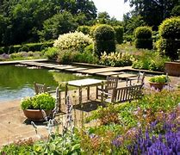

Garden Visits 2024
This is an Open Group so any members welcome. All outings (except where noted) will meet on the 3rd Wednesday of the month, at Forestdale Centre Car Park for 10.45 am, for a 11.00 am get away, returning approximately 5.00 pm to Forestdale Centre Car Park. Contact either Linda Grigsby on 07754 092042 OR Karen Hook on 07799 776684 if you are interested. A donation of £2.50 towards petrol, would be appreciated for the driver of the car you will be travelling in.
22 May 2024 DOWN HOUSE, Downe, Kent BR6 7JT (Was home of Charles
(4th Wednesday) Darwin),
Admission price: £12.00 (£15 on the day), (GW 241 card, EH), gift shop, refreshments, no cash payments, all card payments
19 June 2024 HEVER CASTLE & GARDENS, Edenbridge, TN8 7NG
(Wednesday) Admission price: Group rate: Gardens only - £12.30/£14.55 Castle & Gardens (GW 241 card, NT); refreshments available, also gift shop
17 July 2024 BATEMANS, East Sussex TN19 7DS (was home to Rudyard
(Wednesday) Kipling)
Admission price: £15 (NT, GW 241 card); refreshments, gift shop available
21 Aug 2024 ELTHAM PALACE, Greenwich, SE9 5NP
(Wednesday) Admission price: £14.50 (EH, GW 241 card); refreshments and gift shop available
18 Sept 2024 RIVERHILL HIMALAYAN GARDENS, Sevenoaks, TN15 0RR
(Wednesday) Admission £12 (RHS/GW 241 card); refreshments and shop available

- Botanical Art Course
Would you be interested in a 12-week tutored course in botanical watercolour painting and enjoy exploring the vibrant world of botanical art?
Meeting once a week, the course will include:
Observation and sketching; colour mixing and basic techniques; painting leaves, flowers, stems, branches, bark; painting fine detail; composition, background and texture. Participants will need to have their own equipment – a detailed list of items will be provided.
To express your interest, please contact me at: clockie68@gmail.com
3
Wildflower Group Programme 2024
4th Monday of the month
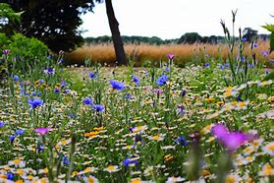

Date | Venue | Meeting point, 10am
May 27th | Happy Valley (Jane to lead) | End of Chaldon Way, off Marlpit Lane
June 24th | Roundshaw Down (Geoff to lead) | Plough Lane, far end
July 22nd | Riddlesdown | Eskdale Gardens
Aug 26th | South Norwood Country Park | Car Park off Albert Road
Sept 23rd | Hutchinson’s Bank | Farley Dene Crescent
Oct 28^{t}h | Fungus Foray, Bramley Bank and Heathfield | Far end of Croham Valley Road
Contact: Shirley Shephard, 0208 657 3144, email sandrshephard@hotmail.com
----------------------------------------------------------------------------------------------------------- ---------------------
Please bring the completed tear-off slip with you as I am required by u3a to have these details.

*Name: ……………………………………………… U3A Membership No:

*Tel No:: ………………………………… *Emergency Tel No:: ……………………………………

Email address: ……………………………………………………………….
-------------------------------------------------------------------------------------------------------------------------------
Join History of London (3)

The History of London groups are some of our most popular groups and are nearly all currently over-subscribed – so are having regretfully to turn away members who would like to join them.
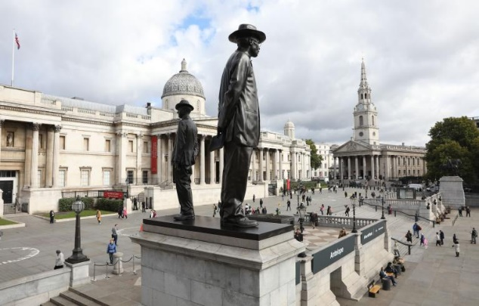
However, History of London (3) does now have a vacancy for somebody to join the group .... if you are able and willing to book speakers!

To help you, there is a list of all the speakers since the group started and a list of contacts from the current organiser. There is scope also for your own ideas and contacts. There is the possibility of 2 people taking on the role as a job-share.

If interested please contact our Groups Co-ordinator clockie68@gmail.com
Line Dancing Fun
Our Line Dancing Group is an enthusiastic group of beginners and intermediates who enjoy getting together on Friday mornings for a session at Shirley Methodist Church.

Line dancing is good for your physical mobility as well as making sure you concentrate on the steps but above all it’s great fun and there are a lot of laughs. Don 't worry about getting it wrong, we all do that! Line dancing is no longer about cowboy hats and boots, although we may use some of the same steps, we now dance to a variety of popular music.

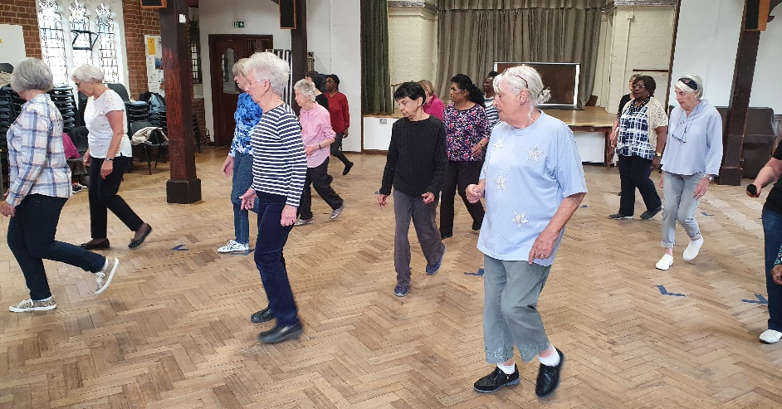
We dance on the first and third Friday of every month at Shirley Methodist Church. We have to cover the cost of our instructor’s time as well as the hire of the hall so at the moment each member pays £5 for each session so that we are able to cover our costs with an opportunity to dance for an extra half hour if you are a slightly more advanced line dancer.

If you would be interested in joining the group, do contact me on joyellery@btinternet.com or leave a message on 07710 244601.

tRACING YOUR ANCESTORS
This small friendly group (previously called Family History) is looking to recruit extra members.
We meet on the 4th Wednesday each month from 2.00 -3.30pm at Thornton Heath library in Brigstock Road. Local buses from Croydon stop right outside the library or Thornton Heath station is less than a 10-minute walk away.
We use the computers in the Library’s IT suite and, if required, members can use my subscription to Ancestry for a nominal charge (currently £1). Other websites are available - but please note not all of these are free to use.
If you are interested in joining the group to learn a bit more about your ancestors, please contact me …
You never know who or what you may find!
Cariss Smith: 0208 668 9562/ carisssmith@gmail.com
Taster Golf Experience – Monday 18 March 2024
On Monday 18 March 6 u3a members attended the above taster golf experience, led by John Doran. Mark Hill’s review of the event was: “that it was very good and the instructor (Alex MacGregor) was excellent and catered to our own personal learning requirements with good encouragement and instruction as required. I think that the group will grow and could be a good interest group to possibly set up. Also in addition to the above a few others, myself included have arranged to go to the driving range for some practice and hopefully continue this on a weekly basis.”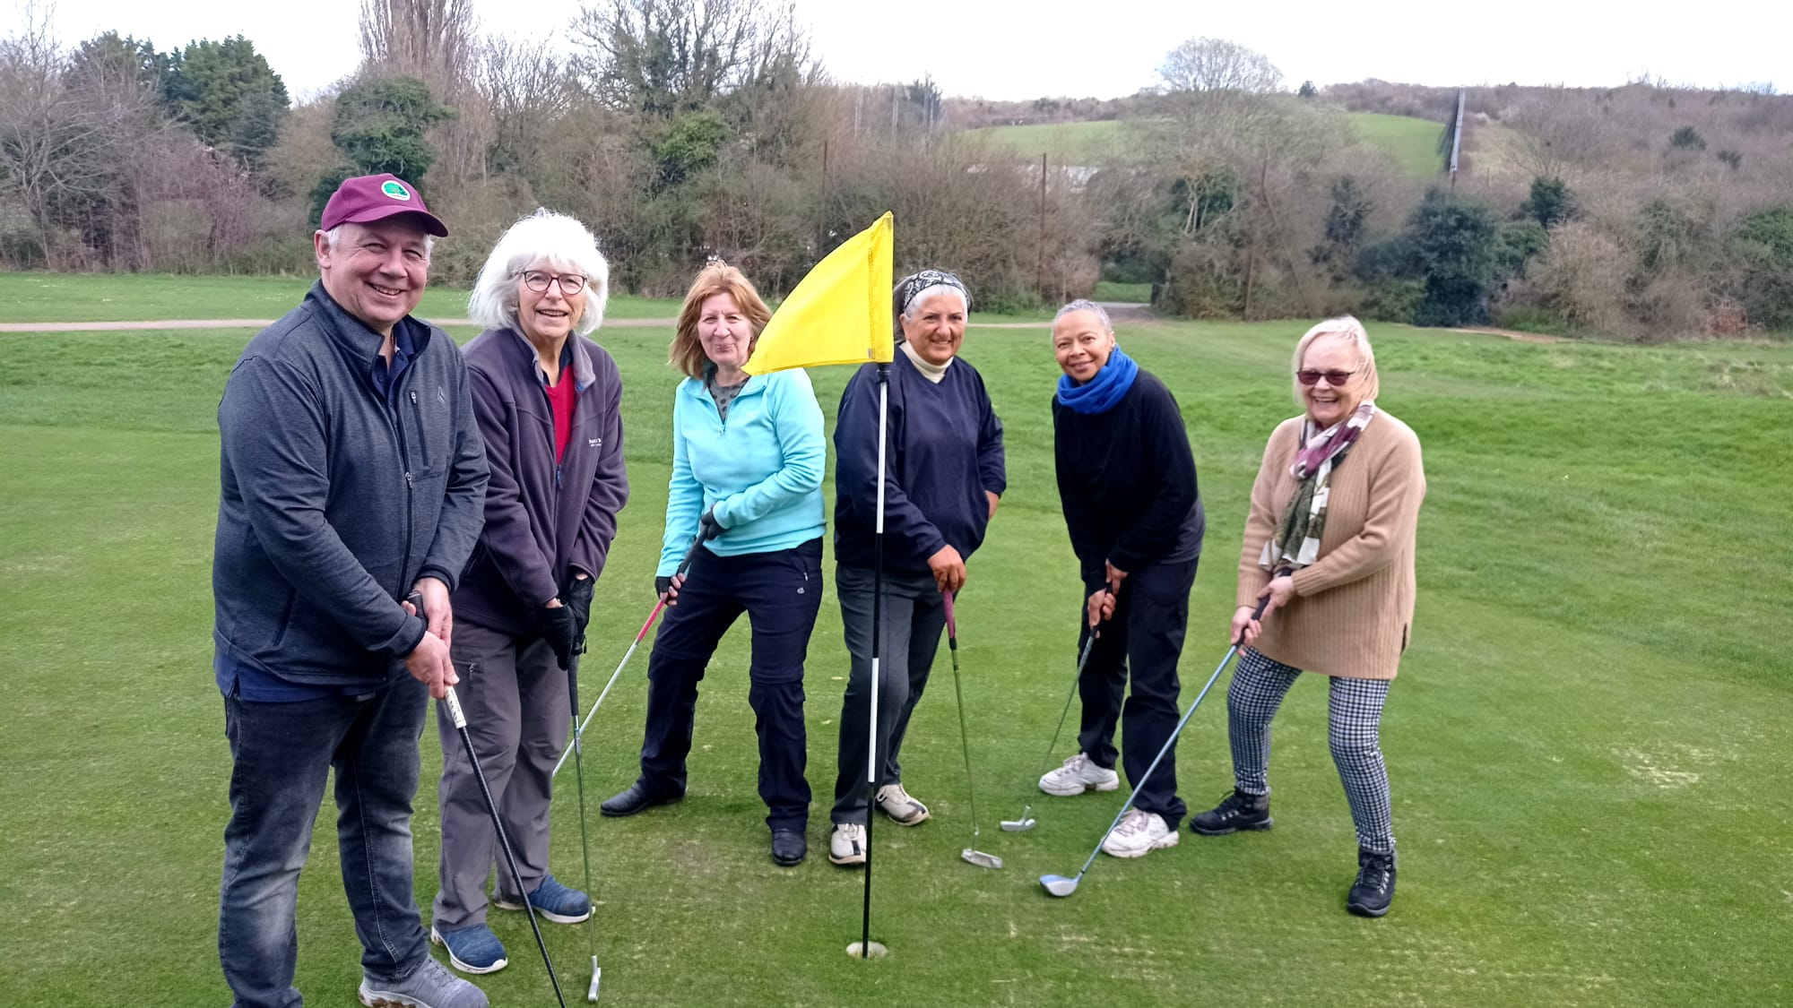

Thanks from the Table Tennis group to David Ryall
After many years as the group leader of the Croydon u3a Table-Tennis group, David has passed on his leadership role to Steve May. During his time David saw the group attendance increase to around 30 members today. This is a testament to his diligent management and welcoming demeanour, appreciated by all.
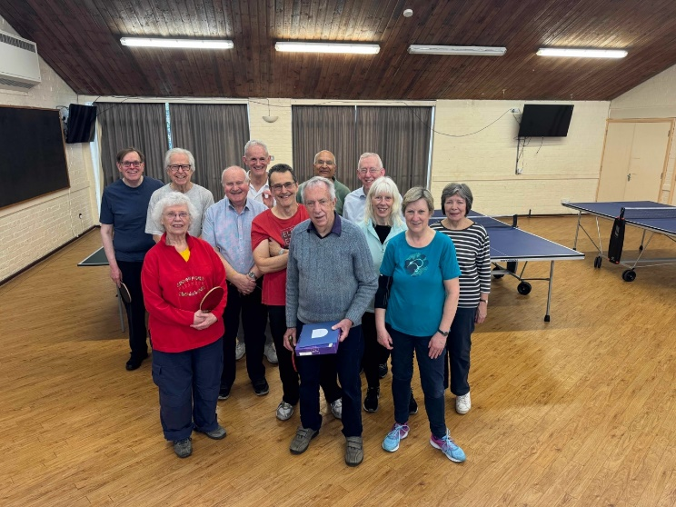
On arrival, members found the table tennis tables already set up, without always realising that it was David who had arrived early to set up those tables and prepare the room so that we could get down to playing. He is a canny and skilful player with some stunning shots in his armoury and we all really enjoy playing with him. However, latterly he has felt the challenge of continuing to compete at his own high level and with the growth in the size of the playing group he found the task of maintaining contact with all members somewhat onerous.

During the recent smooth handover of the leadership role, the immense amount of work he did to keep the club activities running safely and smoothly was brought to light, including over the difficult Covid 19 period. It was at the first session after Covid when four of us arrived at the Church Hall to find the door locked. As a result we all got parking fines because we couldn’t enter our registration details on the screen inside! David actively pursued this with the Church on our behalf and got the fines rescinded.

The many social events he organised were very much enjoyed and David maintained up to date and accurate details of the premises, equipment and members’ details. This was much appreciated when they or their families needed to be contacted during the very occasional medical incidents that have occurred.

We all thank David for his years of service and look forward to continuing playing with him.

