One of the great things about Croydon u3a is that our members keep coming up with ideas for new Interest Groups! It’s worth checking out the website regularly to see what is on offer – and of course the updated Groups’ List is included with your Bulletin.
In this Bulletin, we have information about a prospective new group – ‘Talking Books’ - and also about the ‘Focus on Africa group’ and our new ‘Basic Maths’ course, which are both just getting started.
Maybe you would like to try something creative? If so, the Painting and Drawing group 2 have room for a few more members.
Or are you feeling you need to be more active? Why not join the ‘Line Dancing’ or the ‘Belly Laugh and Fitness’ group? Both could accommodate some more members.
If looking at London’s history is more your thing, our ‘History of London 4’ group has some spaces.
Information about all these groups is to be found in this Bulletin.
Maggie Chan
Interest Groups Coordinator
Garden Visits 2024
This is an Open Group so any members welcome on a first come first served basis. All outings (except where noted) will meet at Forestdale Car Park for 10.45 am, for a 11.00 am get away, returning approximately 5.00 pm to Forestdale Car Park. Contact either Linda Grigsby on 07754092042 OR Karen Hook on 07799 776684 if you are interested. A donation of £2.50 would be appreciated for the driver of the car you will be travelling in.
The new itinerary will be in the March 2024 Bulletin

Painting and Drawing 2
Want to develop your inner Picasso?
Our group offers a friendly environment to draw or paint for relaxation and enjoyment No experience or skill necessary

Meeting every Monday morning from 10.15 to 12.15 at Shirley Methodist Church, Eldon Avenue CR0 8SD
Contact Jan Thorne: 07806 623332 jilling@live.co.uk

5

Garden Design Group
SPRING IS ON ITS WAY
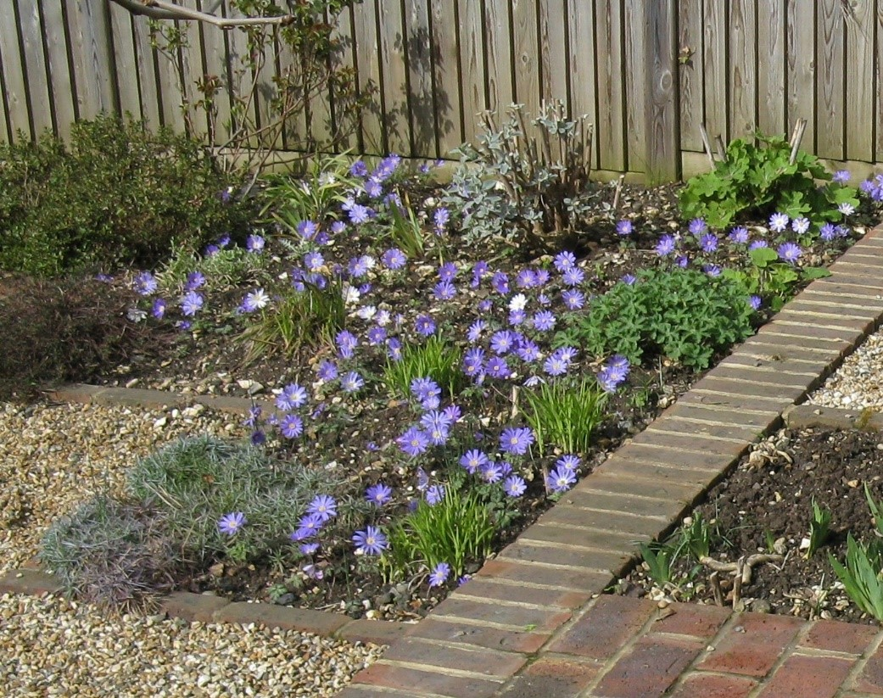
Are you happy with your garden? Does it give you pleasure or is gardening like housework? A well-designed garden should not be a burden or difficult to manage.
Garden Design is run fortnightly on Wednesday mornings from 10 – 12 and takes place at the group leader’s home. It is for people who have an interest in finding out how to make their garden, whatever size, more attractive. The current course is halfway through but the next course is expected to start in February.
If you would like to join or want further information, please contact Betty Whateley, 48 Glossop Rd, South Croydon, CR2 0PU. Tel: 020 8651 0226 Email: elizwhateley@gmail.com

Line Dancing Fun
Our Line Dancing Group is an enthusiastic group of beginners and intermediates who enjoy getting together on Friday mornings for a session at Shirley Methodist Church.

Line dancing is good for your physical mobility as well as making sure you concentrate on the steps but above all it’s great fun and there are a lot of laughs. Don 't worry about getting it wrong, we all do that! Line dancing is no longer about cowboy hats and boots and, although we may use some of the same steps, we now dance to a variety of popular music".

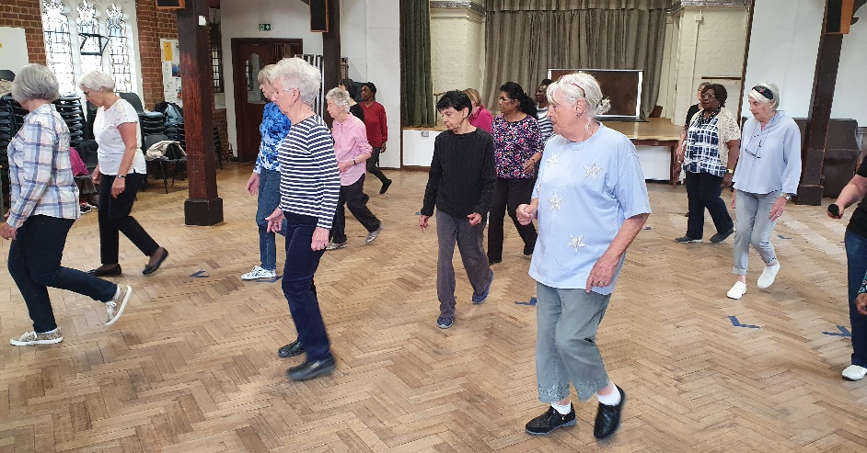
We dance on the first and third Friday of every month at Shirley Methodist Church. We have to cover the cost of our instructor’s time as well as the hire of the hall so at the moment each member pays £5 for each session so that we are able to cover our costs with an opportunity to dance for an extra half hour if you are a slightly more advanced line dancer.

If you would be interested in joining the group, do contact me on joyellery@btinternet.com or leave a message on 07710 244601. We need more dancers!"

tRACING YOUR ANCESTORS
This small friendly group (previously called Family History) is looking to recruit extra members.
We meet on the 4th Wednesday each month from 2.00 -3.30pm at Thornton Heath library in Brigstock Road. Local buses from Croydon stop right outside the library or Thornton Heath station is less than a 10-minute walk away.
We use the computers in the Library’s IT suite and, if required, members can use my subscription to Ancestry for a nominal charge (currently £1). Other websites are available - but please note not all of these are free to use.
If you are interested in joining the group to learn a bit more about your ancestors, please contact me …
You never know who or what you may find!
Cariss Smith: 0208 668 9562/ carisssmith@gmail.com

Darts And Pub Lunch (DAPL) group
Challenge Yourself?

The New Year is a great opportunity to follow through with that resolution and learn a new skill and try something different. Think about what you might like to do now!

Ever considered playing Darts or maybe pick up where you left off all those years ago, meet other members, tackle a team challenge, improve your maths skills and enjoy an inexpensive hearty pub lunch. We meet on the 2nd Tuesday of the month at a local pub in Croydon.
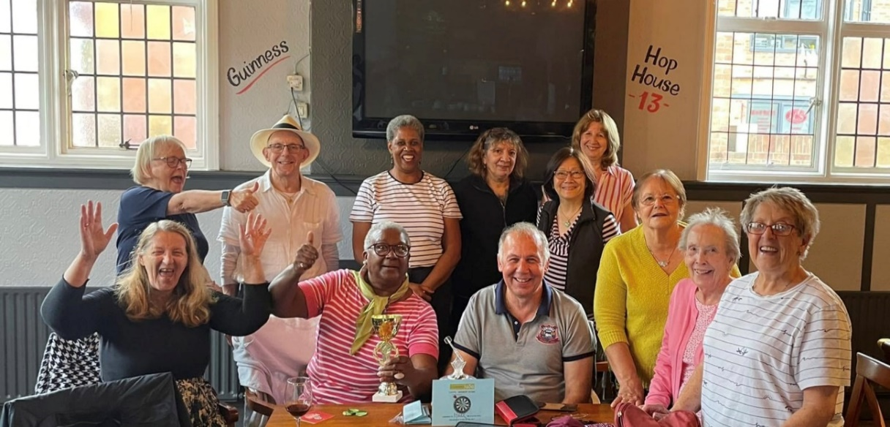
For more information about the Darts And Pub Lunch (DAPL) group contact Jacqueline Harriott, the coordinator through the website www.u3asites.org.uk/croydon

