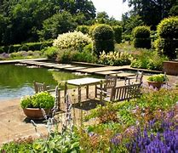

Garden Visits 2024
This is an Open Group so any members welcome. All outings (except where noted) will meet on the 3rd Wednesday of the month, at Forestdale Centre Car Park for 10.45 am, for a 11.00 am get away, returning approximately 5.00 pm to Forestdale Centre Car Park. Contact either Linda Grigsby on 07754 092042 OR Karen Hook on 07799 776684 if you are interested. A donation of £2.50 would be appreciated for the driver of the car you will be travelling in.
17 April 2024 BETH CHATTO GARDENS, Colchester, CO7 7DB
(Wednesday) Admission price: £12.50, (GW 241 card), gift shop, refreshments, no cash payments, all card payments

22 May 2024 DOWNE HOUSE, Downe, Kent BR6 7JT (Was home of Charles
(4th Wednesday) Darwin),
Admission price: £12.00 (£15 on the day), (GW 241 card, EH), gift shop, refreshments, no cash payments, all card payments

19 June 2024 HEVER CASTLE & GARDENS, Edenbridge, TN8 7NG
(Wednesday) Admission price: Group rate: Gardens only - £12.30/£14.55 Castle & Gardens (GW 241 card, NT); refreshments available, also gift shop

17 July 2024 BATEMANS, East Sussex TN19 7DS (was home to Rudyard
(Wednesday) Kipling)
Admission price: £15 (NT, GW 241 card); refreshments, gift shop available

21 Aug 2024 ELTHAM PALACE, Greenwich, SE9 5NP
(Wednesday) Admission price: £14.50 (EH, GW 241 card); refreshments and gift shop available

18 Sept 2024 RIVERHILL HIMALAYAN GARDENS, Sevenoaks, TN15 0RR
(Wednesday) Admission £12 (RHS/GW 241 card); refreshments and shop available

3
Wildflower Group Programme 2024
4th Monday of the month
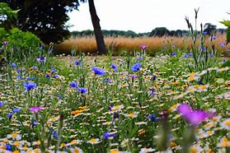
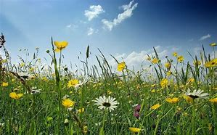

Date | Venue | Meeting point, 10am
March 25th | Foxley Wood | Burwood Avenue, off Oaks Road, an extension of Northwood Avenue
April 22nd | Kenley Common | Golf Road, off Hayes Lane
May 27th | Happy Valley (Jane to lead) | End of Chaldon Way, off Marlpit Lane
June 24th | Roundshaw Down (Geoff to lead) | Plough Lane, far end
July 22nd | Riddlesdown | Eskdale Gardens
Aug 26th | South Norwood Country Park | Car Park off Albert Road
Sept 23rd | Hutchinson’s Bank | Farley Dene Crescent
Oct 28^{t}h | Fungus Foray, Bramley Bank and Heathfield | Far end of Croham Valley Road

Contact: Shirley Shephard, 0208 657 3144, email sandrshephard@hotmail.com
----------------------------------------------------------------------------------------------------------- ---------------------
Please bring the completed tear-off slip with you as I am required by U3A to have these details.

*Name: ……………………………………………… U3A Membership No:

*Tel No:: ………………………………… *Emergency Tel No:: ……………………………………

Email address: ……………………………………………………………….

Line Dancing Fun
Our Line Dancing Group is an enthusiastic group of beginners and intermediates who enjoy getting together on Friday mornings for a session at Shirley Methodist Church.

Line dancing is good for your physical mobility as well as making sure you concentrate on the steps but above all it’s great fun and there are a lot of laughs. Don 't worry about getting it wrong, we all do that! Line dancing is no longer about cowboy hats and boots, although we may use some of the same steps, we now dance to a variety of popular music.

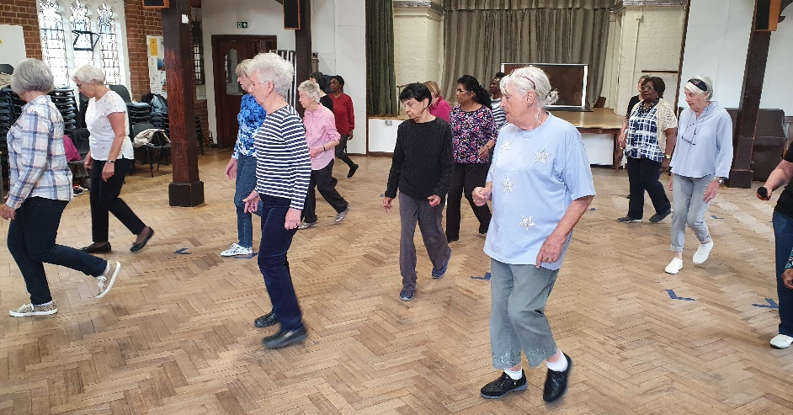
We dance on the first and third Friday of every month at Shirley Methodist Church. We have to cover the cost of our instructor’s time as well as the hire of the hall so at the moment each member pays £5 for each session so that we are able to cover our costs with an opportunity to dance for an extra half hour if you are a slightly more advanced line dancer.

If you would be interested in joining the group, do contact me on joyellery@btinternet.com or leave a message on 07710 244601.

tRACING YOUR ANCESTORS
This small friendly group (previously called Family History) is looking to recruit extra members.
We meet on the 4th Wednesday each month from 2.00 -3.30pm at Thornton Heath library in Brigstock Road. Local buses from Croydon stop right outside the library or Thornton Heath station is less than a 10-minute walk away.
We use the computers in the Library’s IT suite and, if required, members can use my subscription to Ancestry for a nominal charge (currently £1). Other websites are available - but please note not all of these are free to use.
If you are interested in joining the group to learn a bit more about your ancestors, please contact me …
You never know who or what you may find!
Cariss Smith: 0208 668 9562/ carisssmith@gmail.com

Early Medieval History group
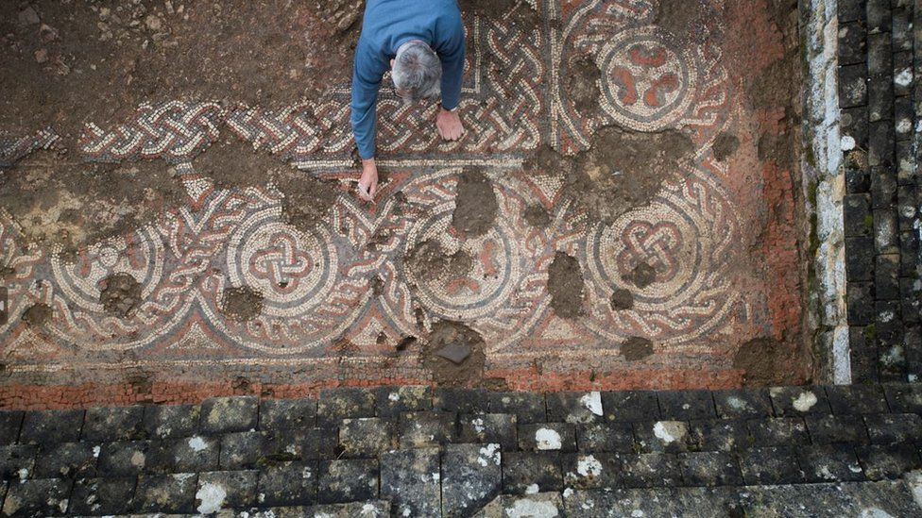
Keen viewers of BBC TV’s Digging For Britain will have seen Alice Roberts as she visited Chedworth Roman Villa in Gloucestershire where the National Trust confirmed sensational dating of a mosaic. The Roman mosaic was discovered in 2020 and further tests have confirmed it was made after the Roman armies left Britain. History books will have to be re-written to say that the Roman way of life continued in some places for much longer than previously thought.
The Early Medieval History group has followed this excavation very closely. Four members visited Chedworth after the discovery and one of them arranged for the National Trust to give us a talk on the discovery. At the time the group was divided over the dating. Some accepted the initial finding citing evidence of mosaic manufacture in nearby Roman Cirencester; others questioned how the villa could have been expanding when most had been abandoned.
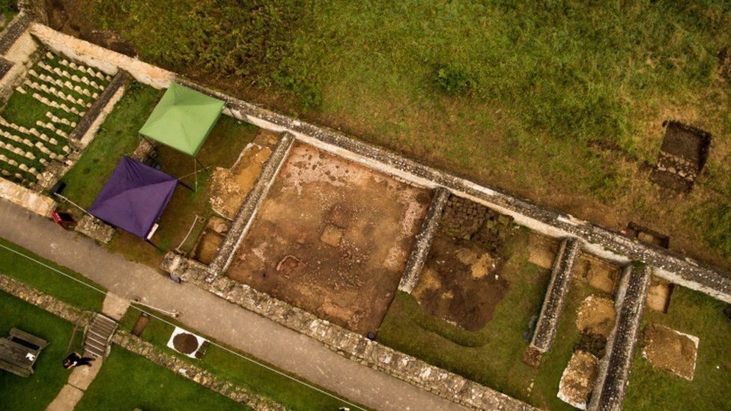
Almost every month the group has been able to re-assess archaeological findings that are constantly bringing Britain’s early history alive. High Speed 2 is undoubtedly controversial but one by-product has been large-scale archaeological digs all the way from London to Birmingham.
The group has looked at the coming of the Anglo-Saxons and the kingdoms in Wales, Ireland and Scotland at this period. The group is now ready to study the coming of the Vikings which should again provoke lively debate. Were they merciless killers and opportunist raiders or were they traders and settlers who, for example, built Ireland’s first cities?
If you enjoy programmes like Digging For Britain why not join the debate as we look at this fascinating period as it literally emerges from the ground by contacting Lindsay Offer 0208 760 5093, email offerfamily@yahoo.co.uk
For picture https://www.bbc.co.uk/news/uk-england-gloucestershire-67947045

