Environment News : Trees4Croydon Campaign Update
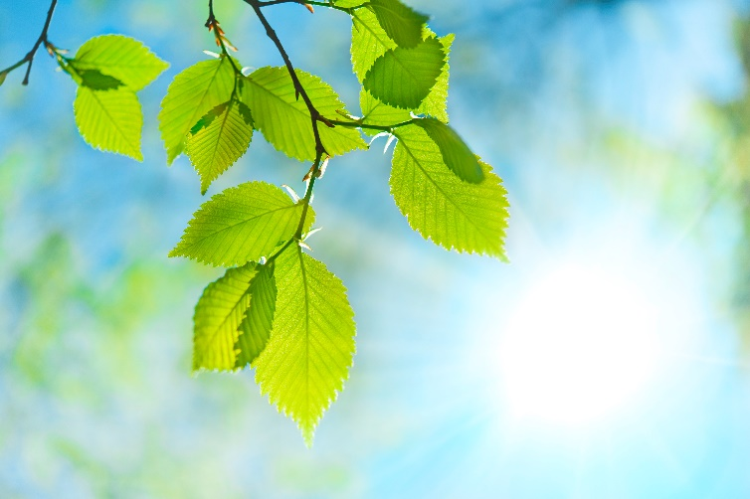

Croydon Climate Action have reported that this has been a huge success, increasing the tree canopy, diversity, health and wellbeing of the local community in Broad Green, one of the most green space deprived areas of Croydon.
‘It was wonderful to see our Croydon Climate Action Members, their friends, families and wider networks pulling together to move the miles in our mass participation Get Moving for Trees Event.’
More money was raised than the organisers ever expected and thank you so much to our members who took part.
‘Despite the freezing temperatures, over 170 enthusiastic volunteers from across Croydon, braved the arctic weather and joined in an absolutely fantastic day of tree planting on Saturday 20th January…’
850 people walked, ran and cycled 30,673 miles to raise funds for mature trees and their aftercare. Money raised was match funded by the Aviva Community Fund and the Save Our Wild Isles Community Fund. The planting event was hosted by Trees for Cities, a Tree Trail activity was put on and there was a woodland storytelling session with puppets, a Brazilian drumming performance and some nature-inspired face painting!
I am so proud that we were able to take part in this and help more of the general public to know who we are and what we are about.
This year’s campaign is about trying to reduce the use of toxic pesticides by the contractors working for Croydon Council who spray roadside verges and parts of some parks and gardens.
If you would like to be more involved in Environment and Climate matters :-
*Visit our dedicated section on the website https://u3acroydon.weebly.com/
* join our Environment and Climate Crisis Group – regular meetings on 3rd Thursday of the month @ 7.30 pm on Zoom and some live meetings from time to time.
Jenny Wilson

