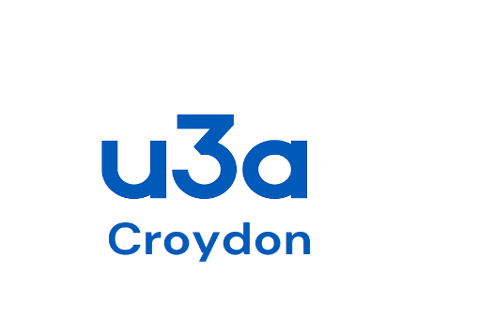 CROYDON u3a – GROUP REGISTER
Name of the Group…………………………………………… Period this form covers ………………………………………………………
Submitted by ……………………………………………………. Telephone number …………………………………………………………….

Please submit this form termly at Christmas, Easter and Summer (31 July) to David Apps, Croydon U3A, 13 Church Way, South Croydon, CR2 0JT (Dapps97090@aol.com) 020 8651 0347
Venue Hire monies to be sent to Paul Smith (Treasurer), Croydon U3A, 26 Morley Road, South Croydon, CR2 0EN (pscsc@msn.com) 020 8651 2682

Does your Group have spaces? YES/NO Does your Group have a waiting list? YES/NO
IMPORTANT: The Group Register needs to be completed and returned regularly to the Croydon u3a committee to ensure that the Group is covered by U3A’s Insurance Policy.
Further copies of this Group Register and/or the Group Register Continuation sheets can be found under Documents on the Croydon u3a Website (u3asites.org.uk/Croydon) or from David Apps (as per above).

CROYDON u3a – GROUP REGISTER Name of the Group……………………………………………
NAME | Tel No: | Membership Number | D | A | T | E |  |  |  |  |  |  |  |  | Emergency Contact Number
Total attendance

