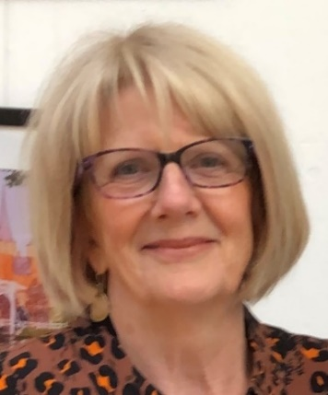  Jenny Wilson  Chair  jennywilson63@live.co.uk | 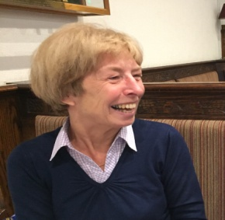  Joy Ellery  Vice Chair/Venues/Archivist  venuehireco-ordinator@croydonu3a.org.uk | 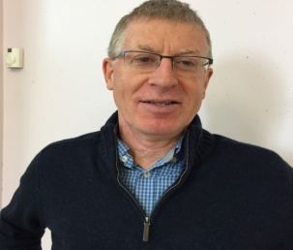  Paul Smith  Treasurer/Membership//Gift Aid/Travel Team  treasurer@croydonu3a.org.uk
Cliff Brett  Committee Member/Publicity | 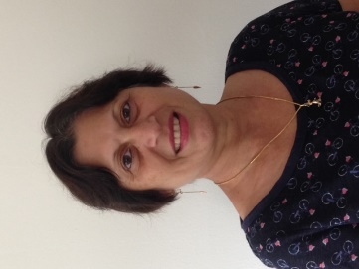  Averil Coutinho  Committee Member/Publicity | 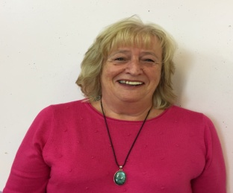  Linda Grigsby  Bulletin/Travel Team/ Publicity  bulletinsecretary@croydonu3a.org.uk
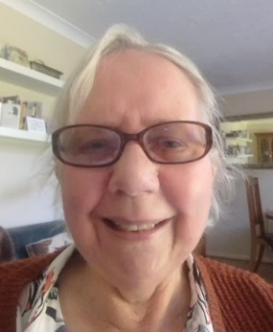  Maggie Chan  Interest Group Co-ordinator/ Publicity  groupsco-ordinator@croydonu3a.org.uk | 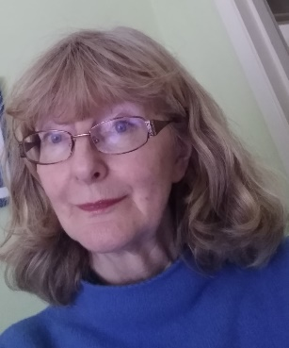  Trisha Holmes  Business/Minutes Secretary businesssecretary@croydonu3a.org.uk | 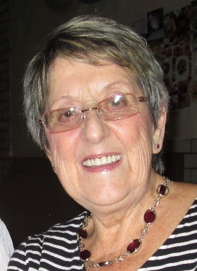  Peggy Green  Committee Member/ Publicity
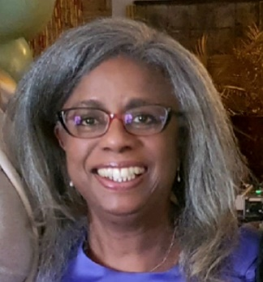  Sheree Yapp-Davis  Inclusion/New Member Liaison | 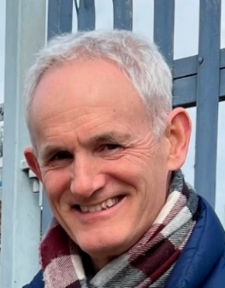  Steve May  Mail Chimp Comm/Committee Member | 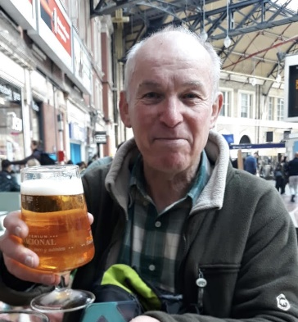  Andy Beaumont  Committee Member

