Architecture

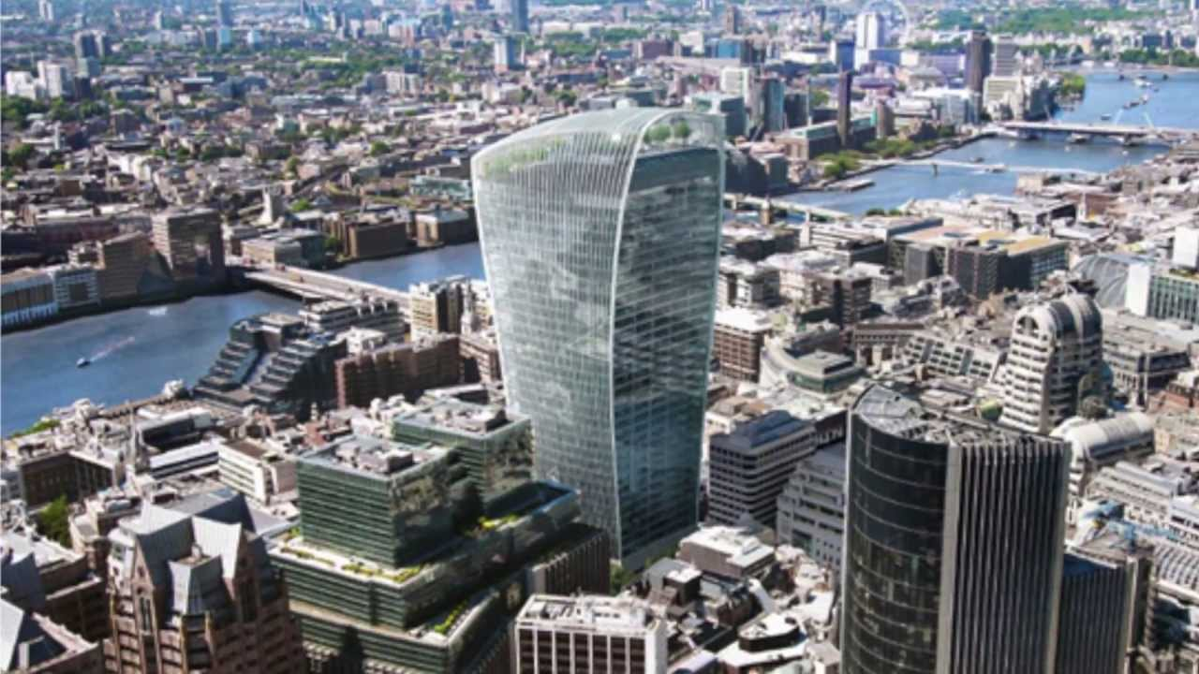

The group visits areas across London and the South East, looking at different architectural themes, with occasional meetings at Purley United Reformed Church.

Visits are mainly within the Freedom Pass area, with some car-sharing.

Meeting on the 1st Monday and 3rd Thursday of the month at 10.00 am.

