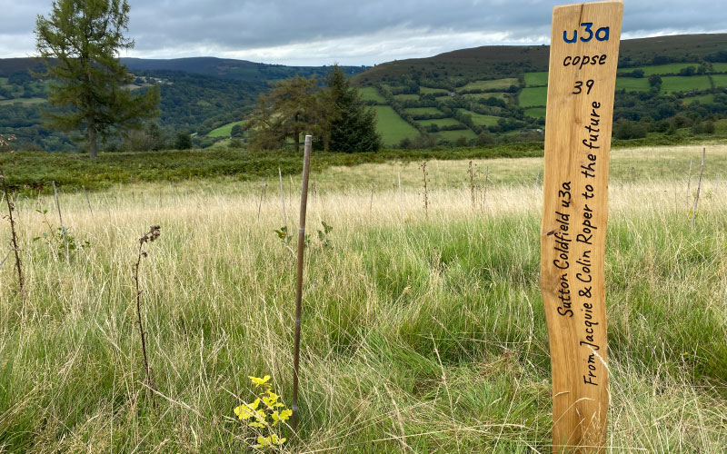

Update on our anniversary woodland
The u3a movement planted almost 10,000 trees as part of our u3a anniversary woodland. We are regularly in conversation with the arborists who look after our woodland. We are delighted that our trees, whilst still very small and growing amidst competitive vegetation, are generally doing well. This is after surviving the hottest and driest summer in south Wales in modern history.
Our woodland is planted for future generations and we will enjoy seeing them take root and grow over the years to become strong and established. We hope to organise a u3a visit at a suitable time in the future when there is more to see.
DECOMPOSITION – HOW LONG?
Paper towel – 2-4 weeks Paper Bag – 1 month
Newspaper - 1.5 months Plywood – 1-3 years
Milk carton - 5 years Cigarette butts – 10-12 years
Plastic containers – 50-80 years Tin steel can – 50 years
Aluminium can – 200- 500 years Foamed plastic cup – 50 years
Plastic bag 200 – 1000 years Monofilament fishing line- 600 years

ZOOM PRESENTATION : The Colours of Hydrogen
Details : Thursday 16th November 2023 at 7.30 pm to be given by John Baxter, the Trust’s New Subject Adviser for Climate Change and The Environment.
This event has been arranged by the Environment & Climate Crisis and the Science and Technology Interest Groups. Members of Croydon u3a are invited to join in. Please note this is a Croydon u3a event – the link should not be shared with non-members without first consulting the Chair Jenny Wilson.
John is also producing a very full and informative free monthly newsletter to keep us up to date with all things climate related. Contact him at :-u3asecondnature@gmail.com for more information about joining the mailing list.
To take part in the Zoom presentation email jennywilson63@live.co.uk to book a place.

