**A FANTASTIC GENERAL MEETING WITH SIR RICHARD STILGOE AND REPRESENTATIVES FROM ORPHEUS COLLEGE**

## ****Inspiring & empowering**** young disabled students to live fulfilling, ****independent lives****.

The Orpheus Centre [www.orpheus.org.uk](http://www.orpheus.org.uk)

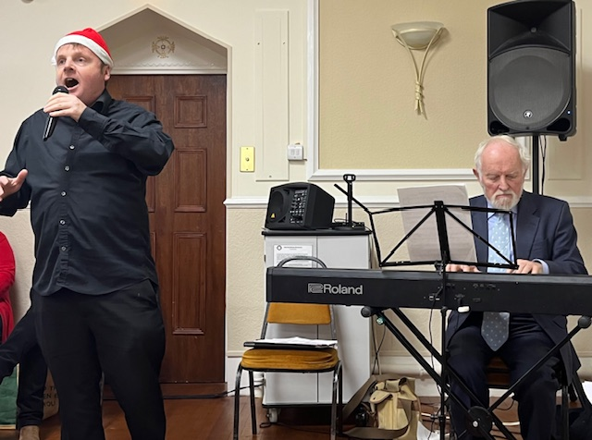We had a really brilliant afternoon at the December General Meeting. Former students from Orpheus College, which offers opportunities to disabled young people from 19 – 25 years of age, entertained us with a selection of Christmas music.

VIP guest, Sir Richard Stilgoe, read two very amusing and topical poems one referring to the great u3a. Thanks to Ann Lovelace, who organised the event.

Members had opportunities to join in the singing and they supported the college by purchasing the lovely items of merchandise.

Angus

Luke

Charlotte

**Photographs by Margaret Derrick**

**3**

**THE SPIRIT OF CHRISTMAS 2023**

The spirit of Christmas – That sounds so last year,

But every Christmas those four words appear,

And cost us so much – plunge us further in debt – we are

Deep in the red like a Christmas Poinsettia.

I don’t think it’s found at the Covid inquiry

While reading out pages from Boris’ diary.

“Eat out to help out” – an idea of Rishi’s

To spread the pandemic while doing the dishes.

Was it out in the jungle with Nigel Farage

Who thought that the nation would put him in charge

If he ate all the rude bits that kangaroos use

Whenever they want to make more kangaroos?

It’s all so confusing – it’s all propaganda.

Are we sending the Elgin Marbles to Rwanda?

Is the spirit alive and somewhere on a train? –

Oh no! The train has been cancelled again!

But fear not – the Spirit’s about to re-enter

And take up its place at the Orpheus Centre,

Where kindness, compassion and friendship all thrive

And thus keep the spirit of Christmas alive.

Where student and teacher and each volunteer

Are joyful, triumphant and full of good cheer.

The Spirit of Christmas now joins u3a!

The Spirit of Christmas – The Spirit of Christmas –

The Spirit of Christmas is **here – now – today!**

