Sailing into the New Year by Ray Pearce
One of my editors has suggested that this month’s topic be the New Year so these are my thoughts on this matter. I am going back to December 1953 when I was on embarkation leave from the army. I was staying with my parents and siblings at our house in the Borough of Crosby just north of Liverpool. It was just before the year’s end when the front door bell rang and it was a telegram boy with a message for Private Pearce (me) to return to my army unit as soon as possible as I was sailing on New Year’s Day from Southampton to Singapore. Secretly I was delighted but my poor mother was so upset as were our neighbours. Not right to send a young boy like Ray overseas they said.
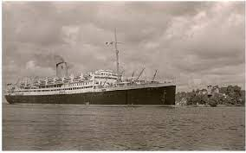
I was 18 and was soon on my way to our depot in Sussex. I was in a draft of five and we spent most of New Year’s Eve getting our tropical kit. It was an early night as we were being taken, early in the morning, by lorry to Southampton docks for embarkation on the good ship Asturias. The cabins were quite cramped and once were had left the Solent the rough seas of The Bay of Biscay awaited us. I was one of many suffering Mal de Mer. Worse still was the fact that the five of us were sent to the galleys “spud bashing”.This involved putting the potatoes into a large revolving drum and when they came out they were pealed but we had to remove the eyes and other blemishes from the potatoes .This lasted about five days when a senior member of our regiment, on his way to Hong Kong found us and took off these duties. Also on board was the 1st Battalion Royal Norfolk Regiment also bound for Hong Kong. By this time we had reached the first week of the year when we called in at The Grand Harbour, Malta to take off an airman to be flown home on compassionate grounds due the illness of one of his parents.

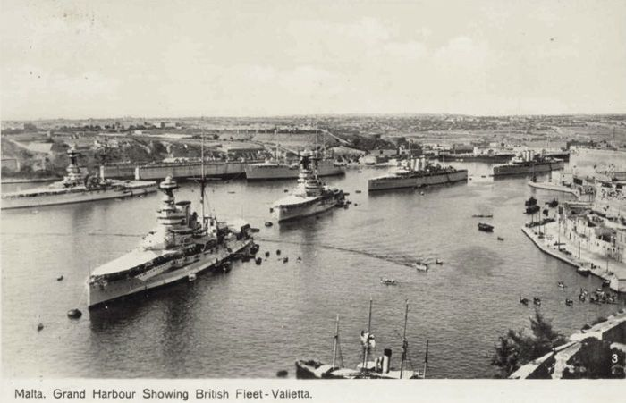
We were allowed ashore at Aden and the five of us hired a taxi to take us into the desert to see The Queen of Sheba wells, this was water not oil. This was part of the Aden protectorate. This would not be possible now as it is now Yemen and bandits have started using drones against shipping in the Strait of Hormuz.
One final happy memory, the old hands on the ship organised an evening of gramophone records, one was by the Pointer Sisters. Another was Vera Lynn singing an old Maori farewell song “Now is the hour for me to say good bye, soon I’ll be sailing far across the sea,” There I was in the middle of the Indian Ocean steaming Eastwards to Ceylon our next port of call. The trip ended on January 23rd 1954, what a lovely start to the year 1954.
Ray Pearce 20.12.23

