Callington u3a 20th Anniversary Newsletter May 2023

Committee News

Following the successful AGM on April 3rd a new executive committee was voted in.
These new executive committee members are :-
Anne- Louise Mellor – Chair
Phil Clift – Vice Chair
Jae Damarell – Treasurer
Pat Mitchell - Secretary
Thanks were given to the outgoing executive members and other committee members, totalling 5 in all who are now standing down. Many thanks were given to them all along with a gift token from u3a Callington for all their hard work, time and effort they have all shown and done over the past years during their service at the AGM.

Introduction to Anne-Louise Mellor, the new Chair of Callington u3a

My name is Anne-Louise Mellor, I am the new Chair of our Callington u3a. I am very excited to take on this new role because I believe the u3a to be a wonderful organisation and in the two years that I have lived in Callington I have gained so very much from being a member of Callington u3a. I moved to Cornwall from Milton Keynes in April 2021, I moved into my bungalow in June and joined the u3a. I subsequently met so many lovely people in the locality and I have made many valuable friendships, thank you for the warm welcome that you have all given me. Additionally, I have really enjoyed taking part in a host of fun activities through u3a: I have loved being shown our beautiful countryside and coastline by
joining the Walkers 1 and Walkers 2 Groups, plus I have learnt about our fascinating local history through our walks. I have greatly enjoyed learning new games and eating delicious homemade cakes with the Game On Group at Lucy’s house and I have learnt to play skittles by joining the Skittles Group. I now have a modicum of success (and a lot of laughs) trying to secure a strike at the Skittles Group that meets in the Treburley Social Club house! When I was Speaker Organiser, I enjoyed meeting some very interesting people and I’ve learnt a lot from their varied and interesting talks during our monthly meetings. The trip to visit the Energy Recovery Centre was very interesting! I hope to encourage lots
more day trips, perhaps to gardens or historical sites in the area. Do let me know if you have a day trip destination in mind or if you would like to organise a day trip. I am looking forward to popping in to visit some more of our fabulous interest groups and meeting more members at the monthly meetings. Please
come and say hello, and also, let me know if there is something you would like to do or something that you think we could do better to improve our u3a. It belongs to us all and is run for everyone’s enjoyment. Let’s have another full year of fun, friendship and a shared joy of life!

Final Membership Subscriptions Reminder
Please note that the subscriptions for 2023 are due for final payment by May 31st. As a reminder the subscriptions payable are:- £13 (no u3a Magazine), £15 (inclusive of magazine), Single membership.
£25 (no u3a Magazine), £29 (inclusive of magazine), joint membership.
Phil Clift, our new Vice Chair has also taken on the role of Membership Secretary and will be at the Birthday Celebration meeting on Monday if you still need to pay your fees before the deadline. Thank you in advance to all members who have already paid promptly and hopefully this reminder will help to jog memories and act as a friendly reminder to clear any outstanding fees due.

Group News

Play Reading
Just a reminder that at last we're back to our regular slot!! The Play reading group will return to its original time to meet on the 1st Thursday afternoon of the month at 2pm at the Library in Callington. New members are welcome to join us for a reading of various selected genre of drama over a cuppa, usually a good laugh, but always good friendship. No experience necessary. Next meeting 1st June. Give it a try. Comedy, Classics, Murder Mystery etc, all copies borrowed from Cornwall Drama Library Service
For more details Contact Sheila Tredinnick on 01579 383717 or email s.tredinnick04@btinternet.com

Jazz Appreciation
Storm Noa raged outside and the wind roaring down Christine’s chimney added a wild improvisation to the tracks we played at this session. Going back to the origins of jazz in the late 19th and early 20th centuries, with its roots in blues and ragtime, we were restricted to choosing recordings from the 1920s and 30s. Appropriate, then, to kick off with so called “Mother of the Blues” Ma Rainey’s guttural voice blasting “Black Cat Hoot Owl Blues”, and another recording by her later from Christine “Jelly Bean Blues”. Cornet player King Oliver and his Creole jazz band was another popular choice, with tracks chosen by Jill – “Slowboat shuffle” – and Christine, “Chimes Blues”, a 1923 recording with Louis Armstrong. More from the 1920s included American scat singer Adelaide Hall, who featured largely in the so-called Harlem Renaissance before moving to London in 1938, where she died in Charing Cross Hospital in 1993 after a career spanning more than 70 years. Ann played “The blues I love to sing”, a track from 1927. So called “King of jazz” Paul Whiteman and his orchestra’s 1926 recording of “The birth of the Blues” was Jill’s choice. Moving on to the 1930s, rich pickings included Roy’s choice of “I found a new baby” by Clarence Williams and Jimmy Johnson – amusing to listen to with the running patter – and another from Roy - Chick Webb and his orchestra with a foot tapping “Stomping at the Savoy”. Phil stuck with First lady of Song Ella Fitzgerald for his choices, with 3 tracks from her epic recordings of the “Great American Songbook”. “S’Wonderful”, the 1934 Cole Porter classic “I get a kick out of you” and a Rodgers and Hart number from the Garrick Gaieties musical. Ann offered Marlene Dietrich singing her own song “Wo ist der Mann” from a 1933 session with Louis Armstrong in Paris, where she was described as “bringing a hint of sulphur…” and a Bechet number, ”Really the Blues”. The latter demonstrated how jazz was progressing from its raw origins in the early 1920s. Derek played the brilliant 1937 Bob Crosby number, “South Rampart Street Parade” evoking images of marching and flag waving; Benny Goodman, playing “Don’t be that way” at the 1938 first ever seated jazz concert in Carnegie Hall, and a number by Lionel Hampton and Teddy Wilson. Jill had us all holding our sides when she played “Hyena Stomp” by Jelly Roll Morton and the Red Hot Peppers – laughter yoga anyone? - and Roy took us to the end of the 30s with Nat King Cole’s Trio, formed in 1939, playing” Sweet Lorraine”. How his voice changed from those early songs to the well-known ones – on this recording, his piano playing is the star! Our next meeting will be on 14th June.
If you fancy joining us or need any further information, please contact Rosemary 01579 370578 or email rosemary.ralph@golitha.uk
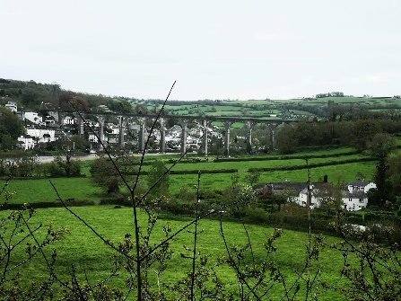
Walkers 1
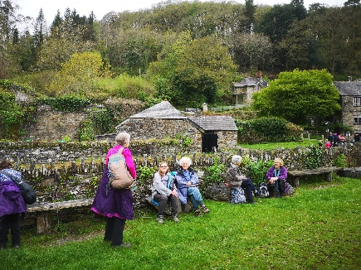
Walkers 1 had a lovely circular walk on Friday 28th April from Calstock to Cotehele. The weather was kind to us and the views beautiful. Thank you Anne for leading the walk.
If you would like to join this group please on email: gjhanns@gmail.com

Walkers 2
Walkers 2 had a lovely walk along the beach in the sunshine on Tuesday 18th April!!
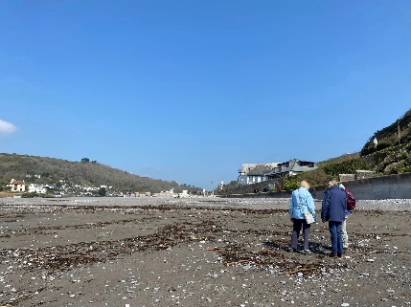
We started out at Seaton and walked along to Downderry. The tide was out so we had plenty of beach, the beautiful red rocks were uncovered and there were lots of beautiful pebbles on the beach! We walked back to Seaton and enjoyed a bacon bap and a coffee sitting in the sunshine! The resident seagulls are getting in practice for the Summer season by clearing people’s plates as they leave and before the staff can clear them away!!
Anybody interested in joining this Group please contact: Helen Redden on 01579 or 07770402242 or email: ladywholunches3@gmail.com

Crime Fiction, TV and Film.
'Why do some very well known authors write novels with co-authors? A question we deliberated after 2 of James Patterson novels were brought to the meeting. 19th Christmas which he wrote with Maxine Paetro and one of the many novels in the Womens Murder Club series and The Murder House with David Ellis. After a little 'Googling' I found Patterson's answer – he says that collaborating with others brings new and interesting ideas to his stories and he is simply more proficient at dreaming up plots than crafting sentence after sentence.
A Boy in the Dark by K McKechnie - Set amongst the hardships of mining families in Cornwall during
the 1850’s and based around the Geevor mine and local area. A young boy descends into the dark world of copper mining to investigate the mystery of his Father's death.
Triple Crown by Felix Francis – This is the younger son of Dick Francis who helped research many of his fathers novels and this one continues with the horse racing theme. Triple Crown of Thoroughbred Racing, commonly known as the Triple Crown, is a series of horse races for three-year-old thoroughbreds in the US. When a British Horseracing Authority investigator is asked to join the United States Anti-Corruption in Sports Agency he goes undercover and discovers corrupt individuals who will stop at nothing—including murder—to capture the most elusive prize in world sport.
Our next meeting will be on May 25th at 2pm. Please come along and share your love of crime fiction, new members always welcome. If you would like to join our group please contact; Yvonne Johnson – johnsonyvonne1@sky.com or 07900913860

Art Appreciation
Les Wyatt gave us a fascinating and humorous presentation on the history and world of the writer, illustrator, artist and cartoonist, Heath Robinson. Born in London in 1872 he started his career as an illustrator of books, mostly those for children. The water babies cover was familiar to most of us, as were some of the illustrations for the fairy tales of Hans Christian Anderson, and of course there were many more, all with his own particular stamp. But his work was not confined solely to books, for he provided designs for Nursery ware used in the decoration of Staffordshire China, and his watercolours, which were his passion, were among his greatest works. Later he became well known for his cartoons, often lambasting the politicians of his day. But of course, he will best be remembered for the complexity and sheer frivolity of his “contraptions”, illustrating his own books called Heath Robinson at War. Indeed, as early as 1912 he gained dictionary recognition and passed into the lexicon of the English language. He was a man of many talents and there is a museum dedicated to his work in Pinner, London where over 1000 drawings reside.
We meet on the 3rd Monday of every month from 2pm until 4pm and discuss many and varied topics. We would be delighted to see you there.
Please contact Penny Beech on 07971889572 or email pennybeech@googlemail.com

Philosophy

This month we tackled Don Cupitt on Non-Realism about God. He has been described as 'the most radical theologian in the world'. Praised by those who see him as making sense of belief in God in the postmodern age. Pilloried by religious traditionalists. Non realism is the view that things don't exist apart from our knowledge of them and ways in which we describe them. He says God doesn't exist apart from our faith in him. Our vision and values change from decade to decade. We have moved on from the late medieval world view. The church has fallen into the past, trying to keep alive a world view that the rest of us have now departed from. He says God is internalised within each believer, as with the Quaker philosophy. He also brought in the stages of human spiritual development from Plato etc to the late 17th century. His conclusion was more or less that we can keep the idea of God as a goal of life, God as a personification or a symbol of love, of perfection. Human kindness, kinship, responsibility to our fellow human being, this is God. His final quote was: Near the end of War and Peace Leo Tolstoy has Pierre say, 'Life is God and to love life is to love God' He was a very interesting person most of the group tended to go along with his thinking and we found some of his philosophy tipped over into Buddhism and others. Our next meeting is in Callington Town Hall Thursday May 25th 10am. It will be John Cottinham on 'The Meaning of Life' not a small subject! Heyho x If you wish to join us in tackling some of life's big questions, come along. Please contact Gillian Brown on email gillian.brown@gmail.com for more information if required.

A new group has stuttered and started - Cards Galore
This is a new club which started in March and following an issue when it was unable to run at short notice in April, for which we are very sorry it is back on track and will be running every 1st Thursday of the month at 10 till 12 in the Council chambers at the Town hall. So come along and join in where you can play a variety of card games. Some old familiar games like Cribbage, Gin Rummy or Pontoon and newer ones like Sevens and Constellation. Or maybe you have a card game you know and would like to teach others, were never too old to learn something new. The session will cost £1.50 to cover the venue and drinks/biscuits. Contact Ann Moore or Carl Moore on 01579 641674 or email aemoore4521@gmail.com for more details.
Date for the diary: The speaker for the June Meeting on June 5th at 10am will be a representative from Treguddick Distillery offering a Gin Talk and Taste experience. After which their goods will be available for purchase.
Please find the invitation to the celebrations below. Thank you
Contact details:-
Anne-Louise Mellor - Chair email: annelouisemellor@gmail.com
Phil Clift - Vice Chair, email: robclift@btinternet.com
Pat Mitchell – Secretary, email: mitchellpa552@gmail.com
Jae Damarell – Treasurer, email: treasurercallingtonu3a@gmail.com
Ann Moore – Newsletter & Publicity 07443414811 email: aemoore4521@gmail.com

