Callington u3a Newsletter January 2023
Committee News
The committee would like to wish all our members a Happy New Year and we look forward to seeing you all at the first meeting of 2023 on Monday 9th January at 10 am. The speaker will be Rachel Reid, from the Environmental Office of Cornwall Council. She will be talking about ‘What happens to our recycling in Cornwall’.

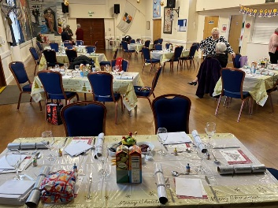
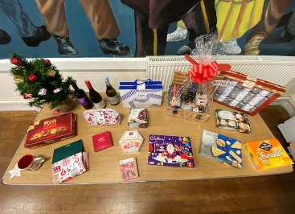
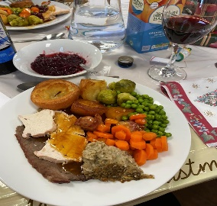
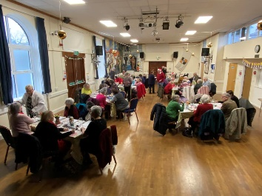

Christmas dinner was another resounding success with 40 members sharing a festive lunch together. Lovely food, a quiz and 22 raffle prizes polished off a great afternoon for everyone.

BOOK SALE - Anita will be holding a Book Sale with everything 2 for 1 at the meeting. Can you please hold onto any book donations you may have until February please. Thank you in advance.
Jazz Appreciation
The Christmas Theme for the December meeting was enjoyed with some mince pies and shortbread. Various tracks including Merry Christmas Baby, Winter Wonderland, A Child is Born, Rocking around the Christmas Tree, Silent Night and Baby its cold Outside. Let it Snow, Let it Snow, Let it Snow was taken seriously by the weather and we are all waiting for it to go.The first Meeting of the New Year will be on Wednesday 11th January at Christine’s as usual and it will be members favourite choices. If you would like any further information, please contact Rosemary 01579 370578 rosemary.ralph@golitha.uk
Walkers 1
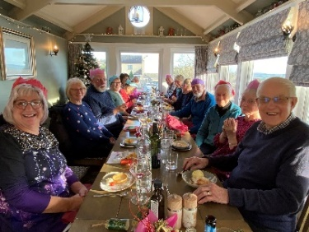
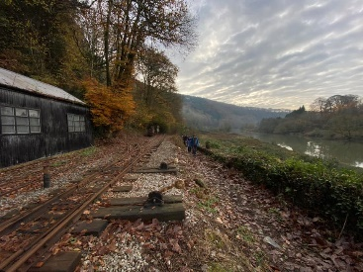
What a beautiful cold and frosty morning we had on Friday 2nd Dec for our walk! Walkers 1 (lead by Anne Sleep) did a lovely circular route around Morwellham. The mist was still in the valley and looked amazing as the sun shone through the mist and the trees. We were glad to see the Autumn colours were still hanging on in the beech trees. The old mine railway looked sadly abandoned and Morwellham Quay was very quiet too. Thank you Anne for a great walk.
Walkers 1 finished off the year with a really lovely lunch last Friday 16th Dec at the Riffle Volunteer! We enjoyed good company, good food and lots of laughter! Thank you Roly for organising us all!!
If you would like to join this group please on email: gjhanns@gmail.com
Baking Group
Everyone was in festive spirits for our December meeting. It was the first time for some while that everyone was present so good to catch up and we fuelled the Christmas atmosphere with glasses of mulled wine.
The table groaned with seasonal bakes and we all tasted everyone- quite a feat when there are so many of us! For the savouries there were squash, sage and chestnut rolls. Christmas Rotolo - which was a dish of pasta and pulled pork, and vegetarian sausage rolls. The sweet dishes included pavlova with spiced plums, spiced ginger Bundt cake, stollen, millionaire’s shortbread and mincemeat custard tarts.
Our January meeting will be recipes using leftovers!

Crime Fiction, TV and Film.
Due to holidays and family commitments the group will be taking a break until after Christmas.
Our next meeting will be Jan 26th 2023.
If you are interested in joining us, please contact Yvonne 07900913860, email johnsonyvonne1@sky.com or add your name to the list at the next monthly U3A meeting.
Italian Group
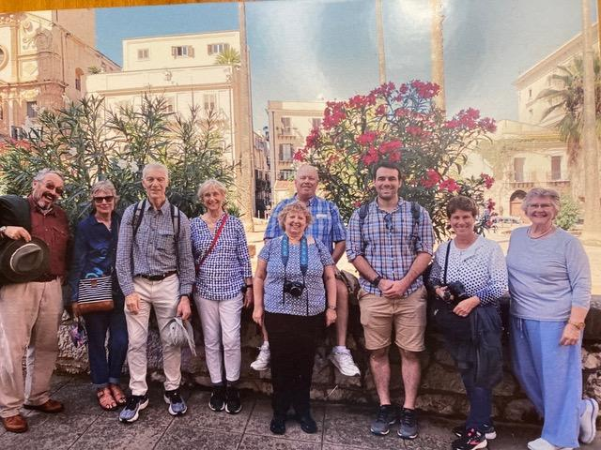
In October some of the Italian group took part in a ‘Responsible and Cultural trip in Authentic Sicily’.
There were five of us from the Callington area and four Americans. It was a busy week which included visits to Palermo, Monreale, Sagesta, Trapani, Erice, Mazara and Marsala.
We learned more about the Mafia and visited Antonio who witnessed the aftermath of the assassination of Judge Falcone by the Mafia thirty years ago.
Much of the holiday involved food, from tastings to a cookery lesson in a housewife’s kitchen. We were able to try some authentic dishes which included Palermo street food, cannoli, pasta alla Norma, Pantesca salad. and couscous alla Trapanese.
The Italian group is now having a break for the winter and will meet again in the spring.

Humour Group
The next meeting of the Humour Group will be on 16th January 2023 meeting in the Townhall Council Chambers at 10am. Please could all members make a concerted effort to attend so we can discuss the way forward.
Helen Redden Group Convenor 01579 382612 or email ladywholunches3@gmail.com

Quiz group
We had a lovely festive meeting in December. We had enough members for 3 teams of 5. Anita set a good quiz for us. There were mince pies and cream for our half time break. New members always welcome. Our next meeting is on Wednesday 4th January at 2pm. Cost £1 per person. Please contact me if you would like to come along.

Skittles group
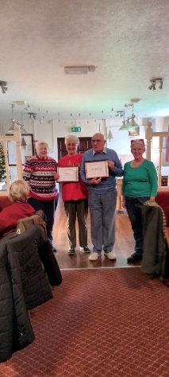
We had a lovely festive meeting in December. Lots of Xmas jumpers in evidence. Cindy our host put on a lovely Xmas buffet. We awarded certificates to the highest scoring lady, Jo and gentleman, Ray in 2022. Our next meeting is on Thursday 19th January. New numbers very welcome. The cost is £1 for the skittles and £5 for the buffet lunch.
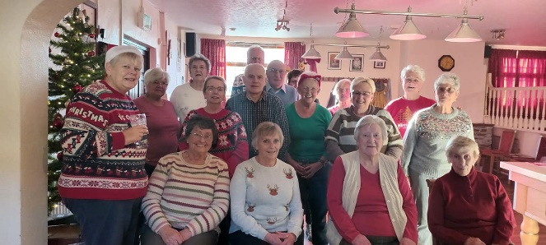
Please contact me if you would like to come along. Mel Hammond

Date for the diary: the speaker for the February meeting on the 6th will be Pamela Vass with ‘Breaking the mould’. A talk about the suffragettes movement in the south west.
Contacts
Yvonne Johnson – Chair, 07900913860 email: johnsonyvonne1@sky.com
Ray Lawrence - Vice Chair, 01579 384594 email: rayg8awb@gmail.com
Jo Earl – Secretary, 01579 532024 email: greenjo1951@gmail.com callingtonu3a@gmail.com
Norman Watts – Treasurer, 01752 845466 email: nhw5100@aol.com treasurercallingtonu3a@gmail.
Ann Moore – Newsletter Editor, 07443414811 email: amcalpin007@aol.com

