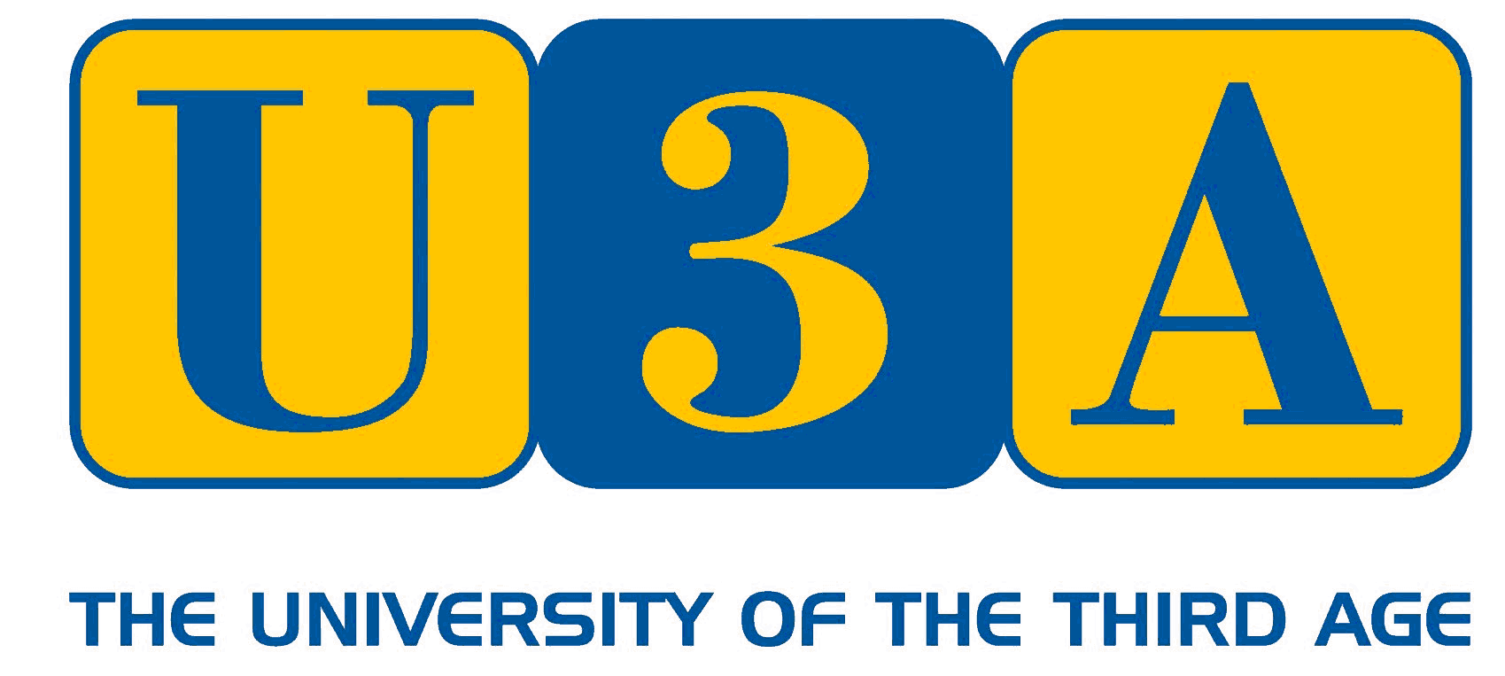
Braunton & District U3A.

Data Protection Privacy Statement.
In joining Braunton U3A you are giving us permission to use the information you have supplied in the following ways:
- To store it securely for membership purposes.
- To communicate with you as a U3A member.
- To share with group leaders, for those groups of which you are a member.
- To send you general information about the Third Age Trust.
We will not share your data with any 3rd parties unless you sign below to give permission for your data to be added to the mailing list for the free magazine “Third Age Matters” which will be sent to you by post. It will not be shared elsewhere.

Signed………………………………………………………………

Print Name …………………………………………………….

