Braunton and District U3A Art Group
We are a small friendly group, who would like to welcome more members. It doesn’t matter what level you are beginner to advanced, we help each other and are bound by our love of painting and sketching. We meet every Tuesday at the Vivian Moon Centre from 2pm-4pm. If you would like to try, come along and join us, you would be very welcome.
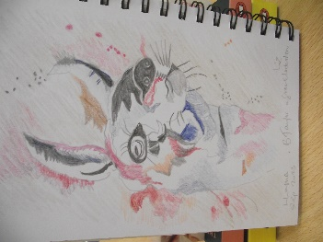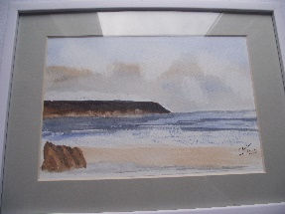
Barry Taylor Joan Ainsworth
Coloured Pencil Water Colour
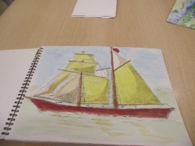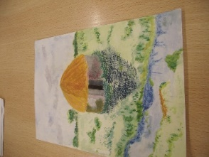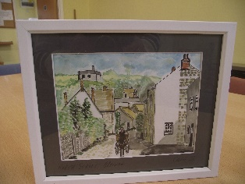
Peter Sims Margaret Taylor Carol Agnew
Water Colour Water Colour Water Colour & ink
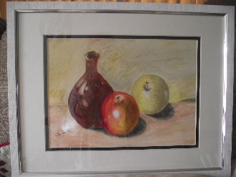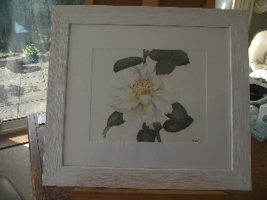
Daphne Benett Oil Pastels Alison Latham Water Colour

