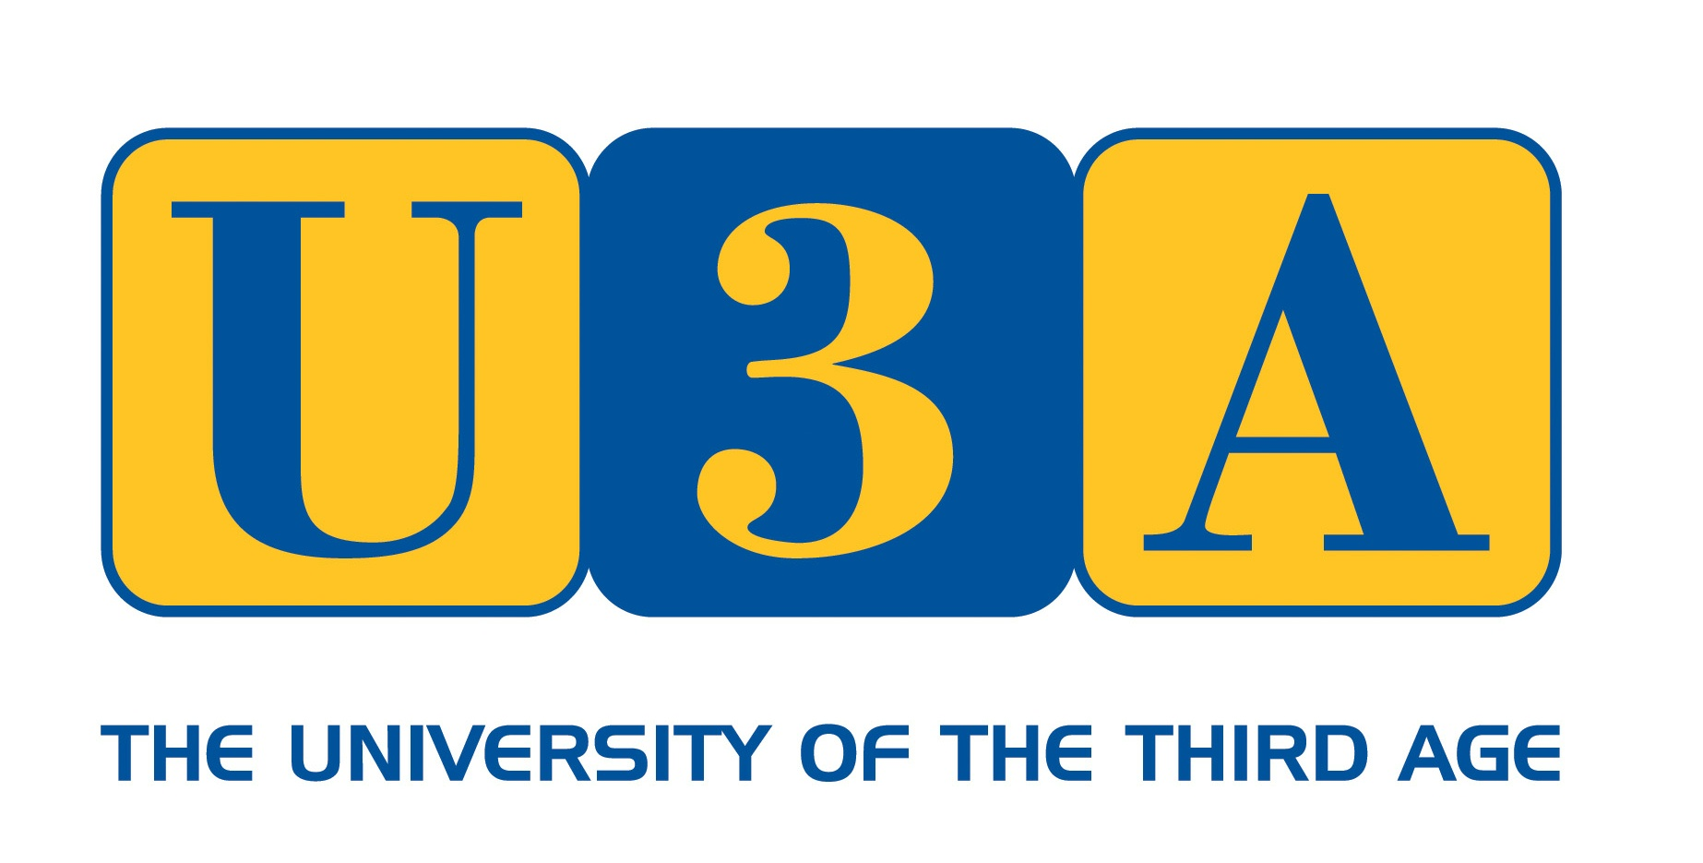
MEMBERSHIP APPLICATION FORM FOR BRAUNTON & DISTRICT U3A -2024
Registered Charity No 1168703
PERSONAL DETAILS
Title & Full Name
Address
 |  | POSTCODE
Telephone | Landline | Mobile
Email Address
N.B. To save costs, the committee will use email whenever possible
MEMBERSHIP FEES
The membership year of Braunton & District U3A is 1st April to 31st March.
Single Annual Membership is £15 This includes a £3.50 Subscription Fee to our national organisation, The Third Age Trust, which provides a wide range of services and benefits, including liability insurance cover. The
cost of the Direct Mail Scheme of £2.50 is also included. Please make cheques payable to Braunton & District U3A
Meetings will be held at Braunton Parish Hall on the first Tuesday of the month at 10.30am when completed applications can be handed to Membership Secretary, Brian Gilbert
TERMS AND CONDITIONS OF MEMBERSHIP
All members must :
- Abide by the Aims and Guiding Principles of the U3A movement.
- Always act in the best interests of the U3A and never do anything to bring the U3A into disrepute.
- Abide by the terms and conditions of the constitution.
- Treat fellow members with respect and courtesy at all times.
- Comply with and support the decisions of the elected committee.
- Advise the committee of any change in your personal details.
PRIVACY STATEMENT
Your personal details will be held on a secure database and will be used solely for the purposes of administration and the communication of U3A matters. They will never be supplied to an outside agency or party other than for you to receive Third Age Matters directly mailed.
I apply for membership of Braunton & District U3A and confirm that :
- I will comply with the terms and conditions of membership as stated above.
- I have completed the form myself.
- I have enclosed a cheque made payable to Braunton & District U3A for £15.00
Signed
Dated

